Varun Khadayate

A016

B. Tech (CsBs) TY

# Aim

Installation of Oracle VM and Ubuntu on Windows OS.

# Software Used

Windows 11, Chrome, Oracle VM, Ubuntu, UTorrent.

# Theory

## What is meant by virtualization?

Virtualization uses software to create an abstraction layer over computer hardware that allows the hardware elements of a single computer—processors, memory, storage and more—to be divided into multiple virtual computers, commonly called virtual machines (VMs). Each VM runs its own operating system (OS) and behaves like an independent computer, even though it is running on just a portion of the actual underlying computer hardware.

## What is Virtual Machine

A virtual machine, commonly shortened to just VM, is no different than any other physical computer like a laptop, smart phone, or server. It has a CPU, memory, disks to store your files, and can connect to the internet if needed. While the parts that make up your computer (called hardware) are physical and tangible, VMs are often thought of as virtual computers or software-defined computers within physical servers, existing only as code.

## What is Oracle VM VirtualBox

Oracle VM VirtualBox is cross-platform virtualization software. It allows users to extend their existing computer to run multiple operating systems including Microsoft Windows, Mac OS X, Linux, and Oracle Solaris, at the same time. Designed for IT professionals and developers, Oracle VM VirtualBox is ideal for testing, developing, demonstrating, and deploying solutions across multiple platforms from one machine.

# Steps to install Oracle Virtual Box/Machine on WindowsOS

## Visit Oracle official Website Link : <https://www.virtualbox.org/wiki/Downloads>

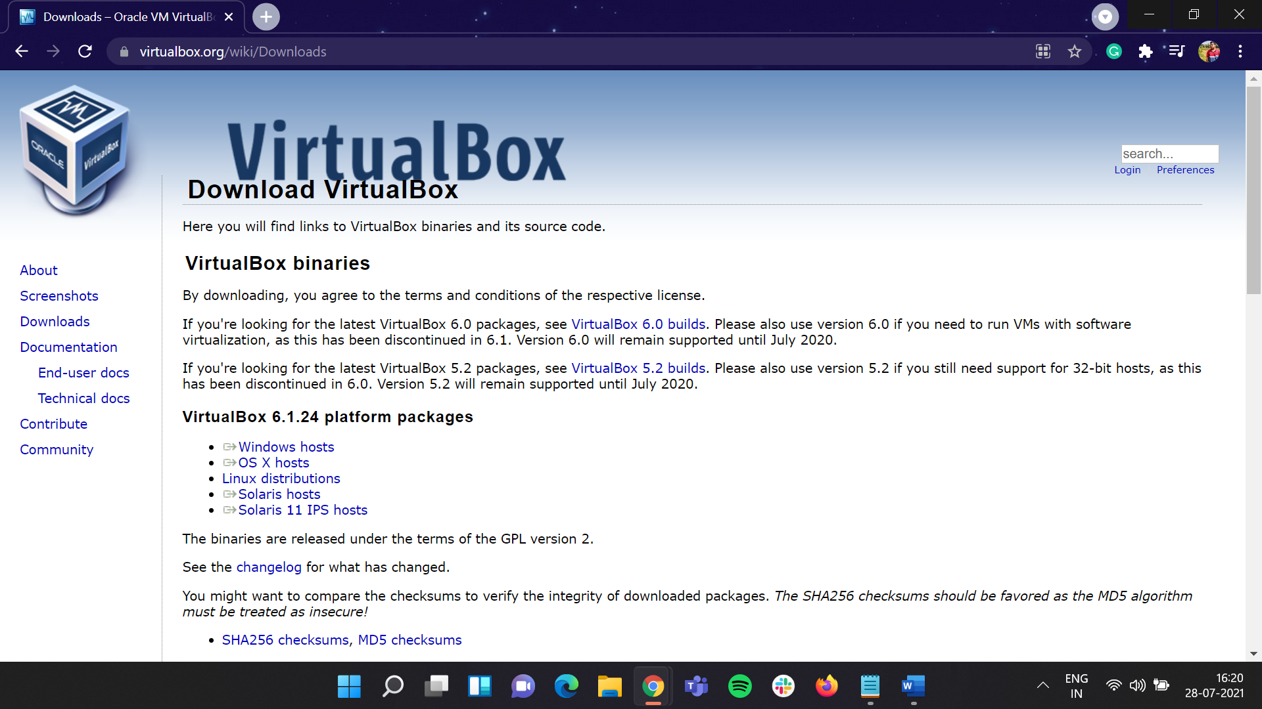

## Under **VirtualBox 6.1.24 platform packages** click on **Windows hosts**

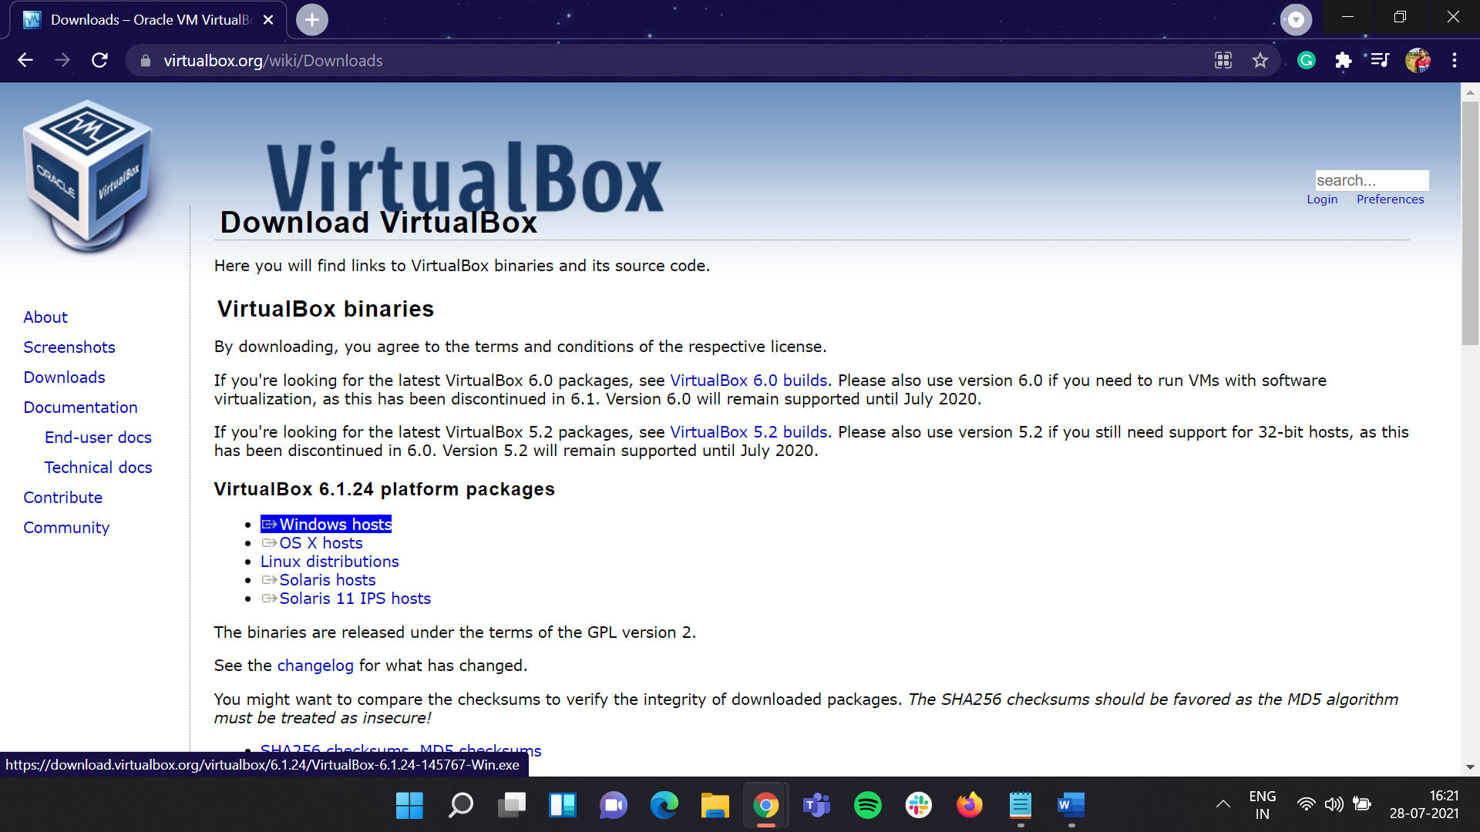

## Download of **VirtualBox 6.1.24 Windows** version will download. Wait for some time to complete the download.

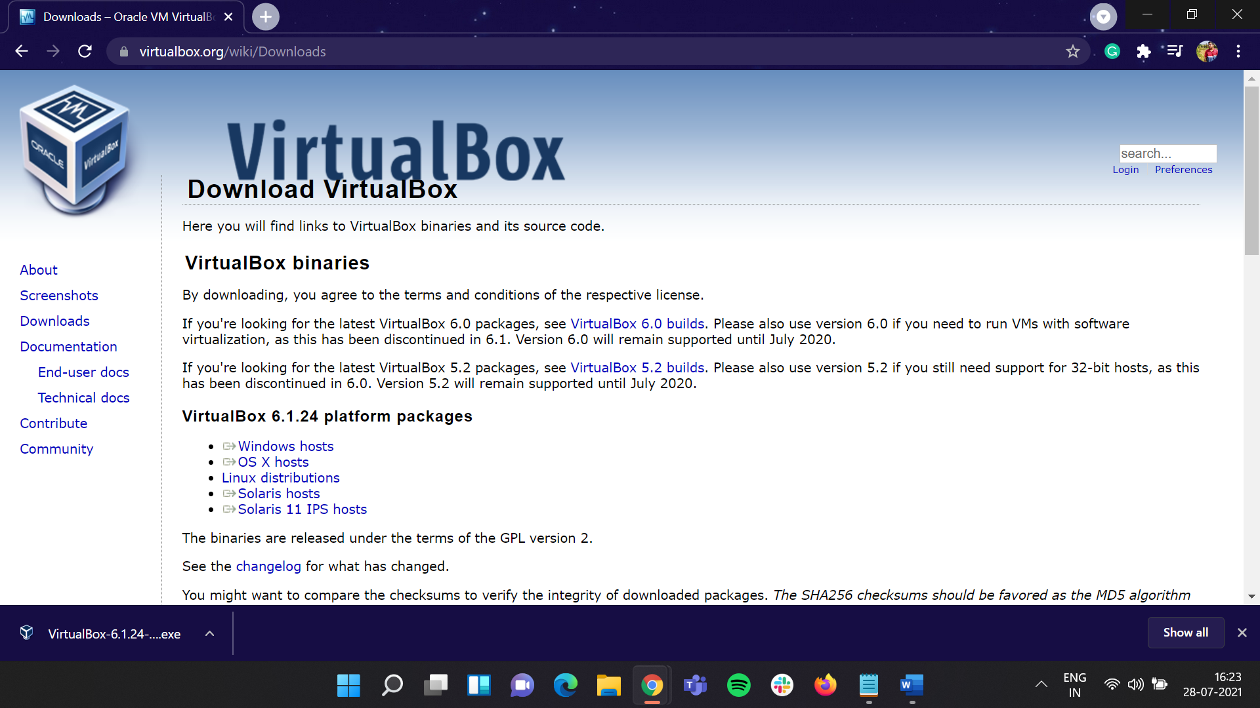

## Once the download has been done double click on it

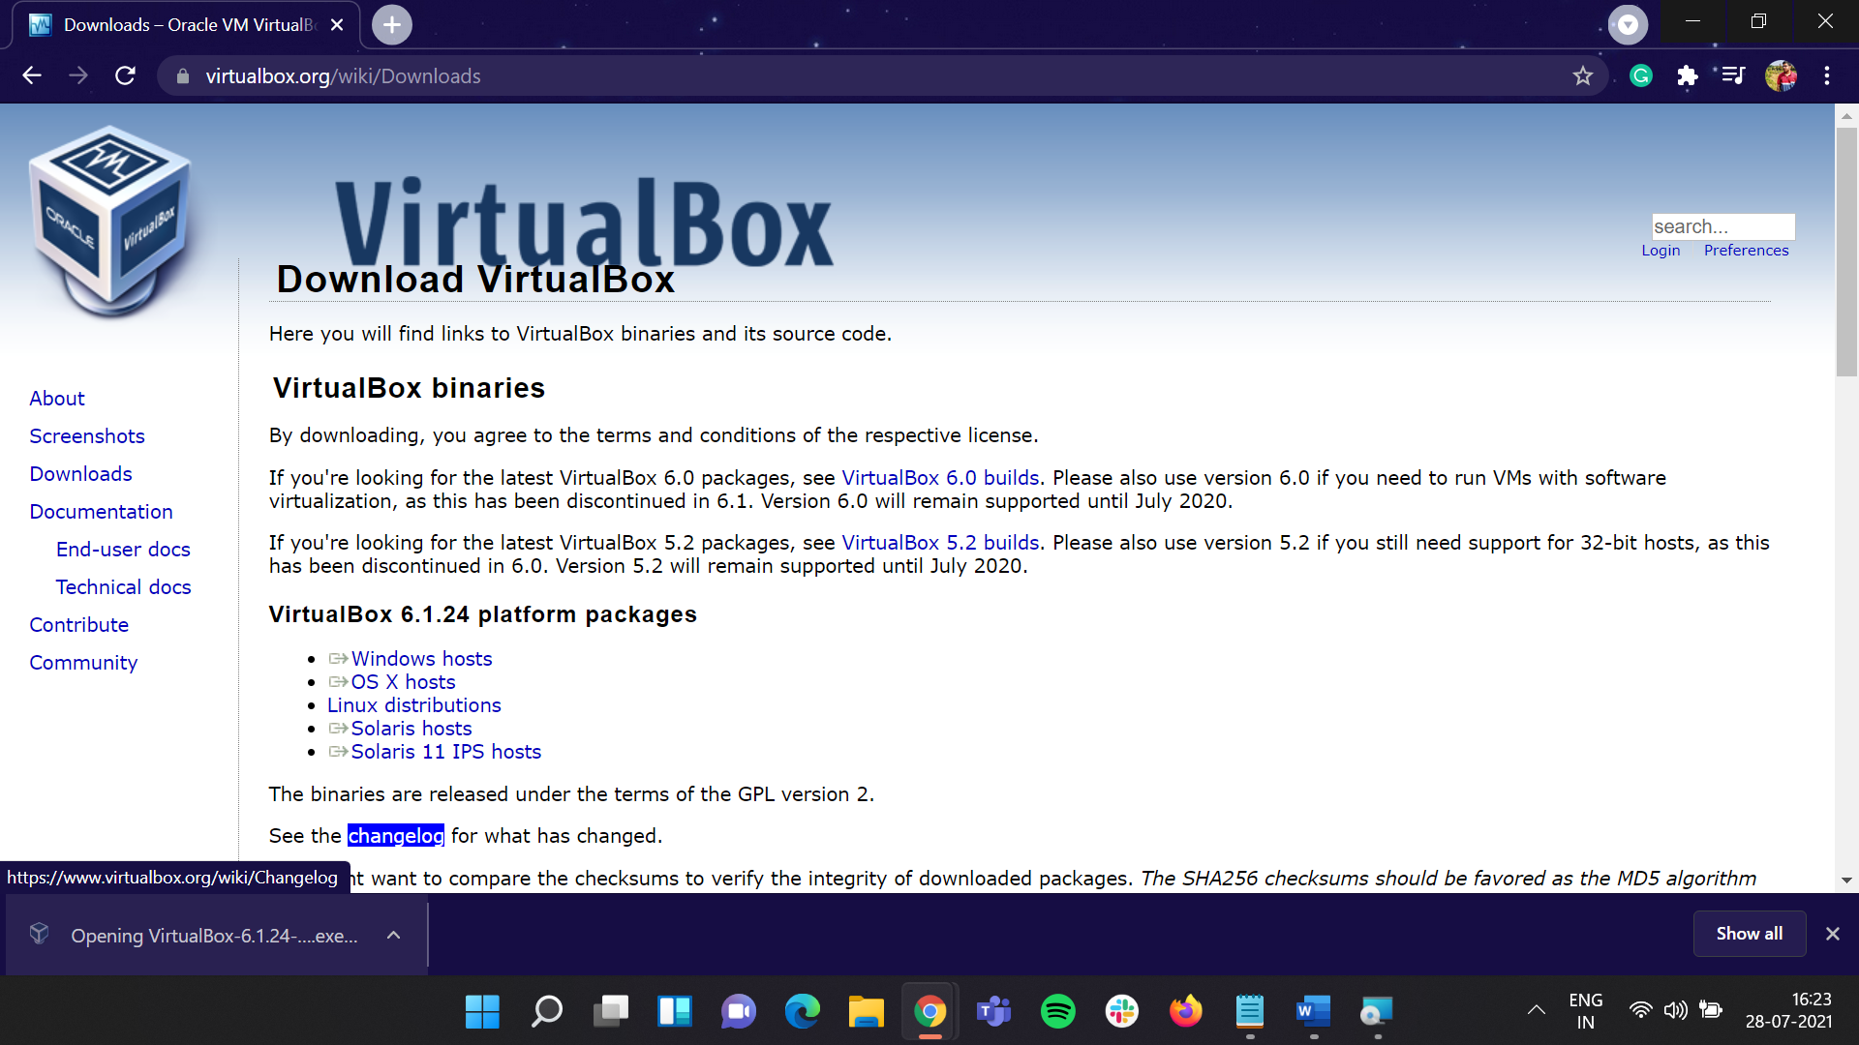

## **VirtualBox 6.1.24 Setup Wizard** will start up, click on **Next** button to proceed further.

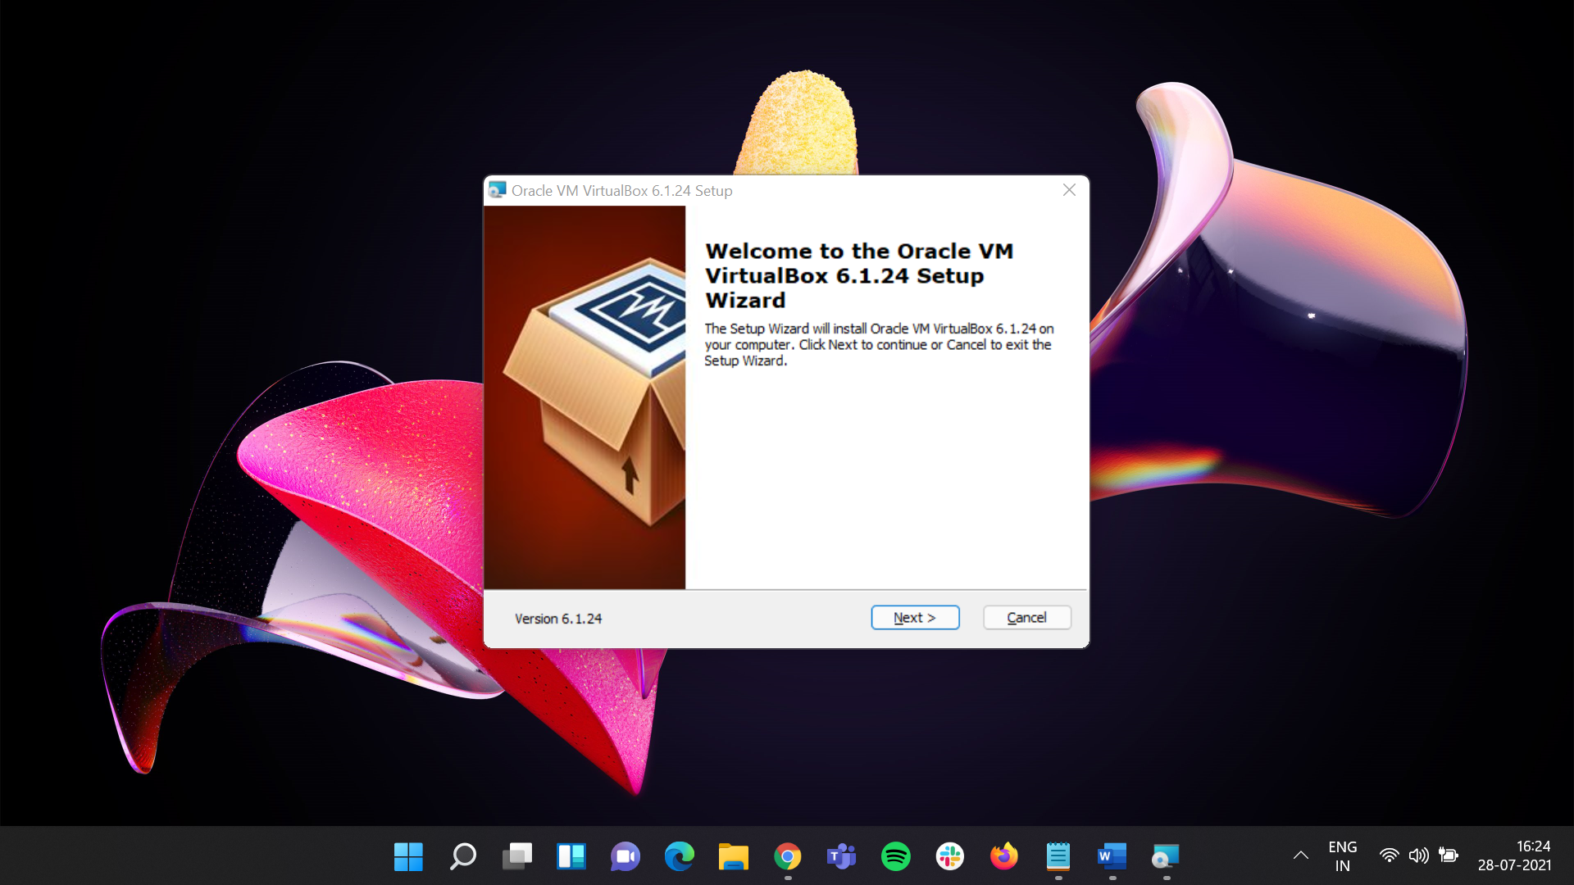

## Click on **Next** button to proceed further.

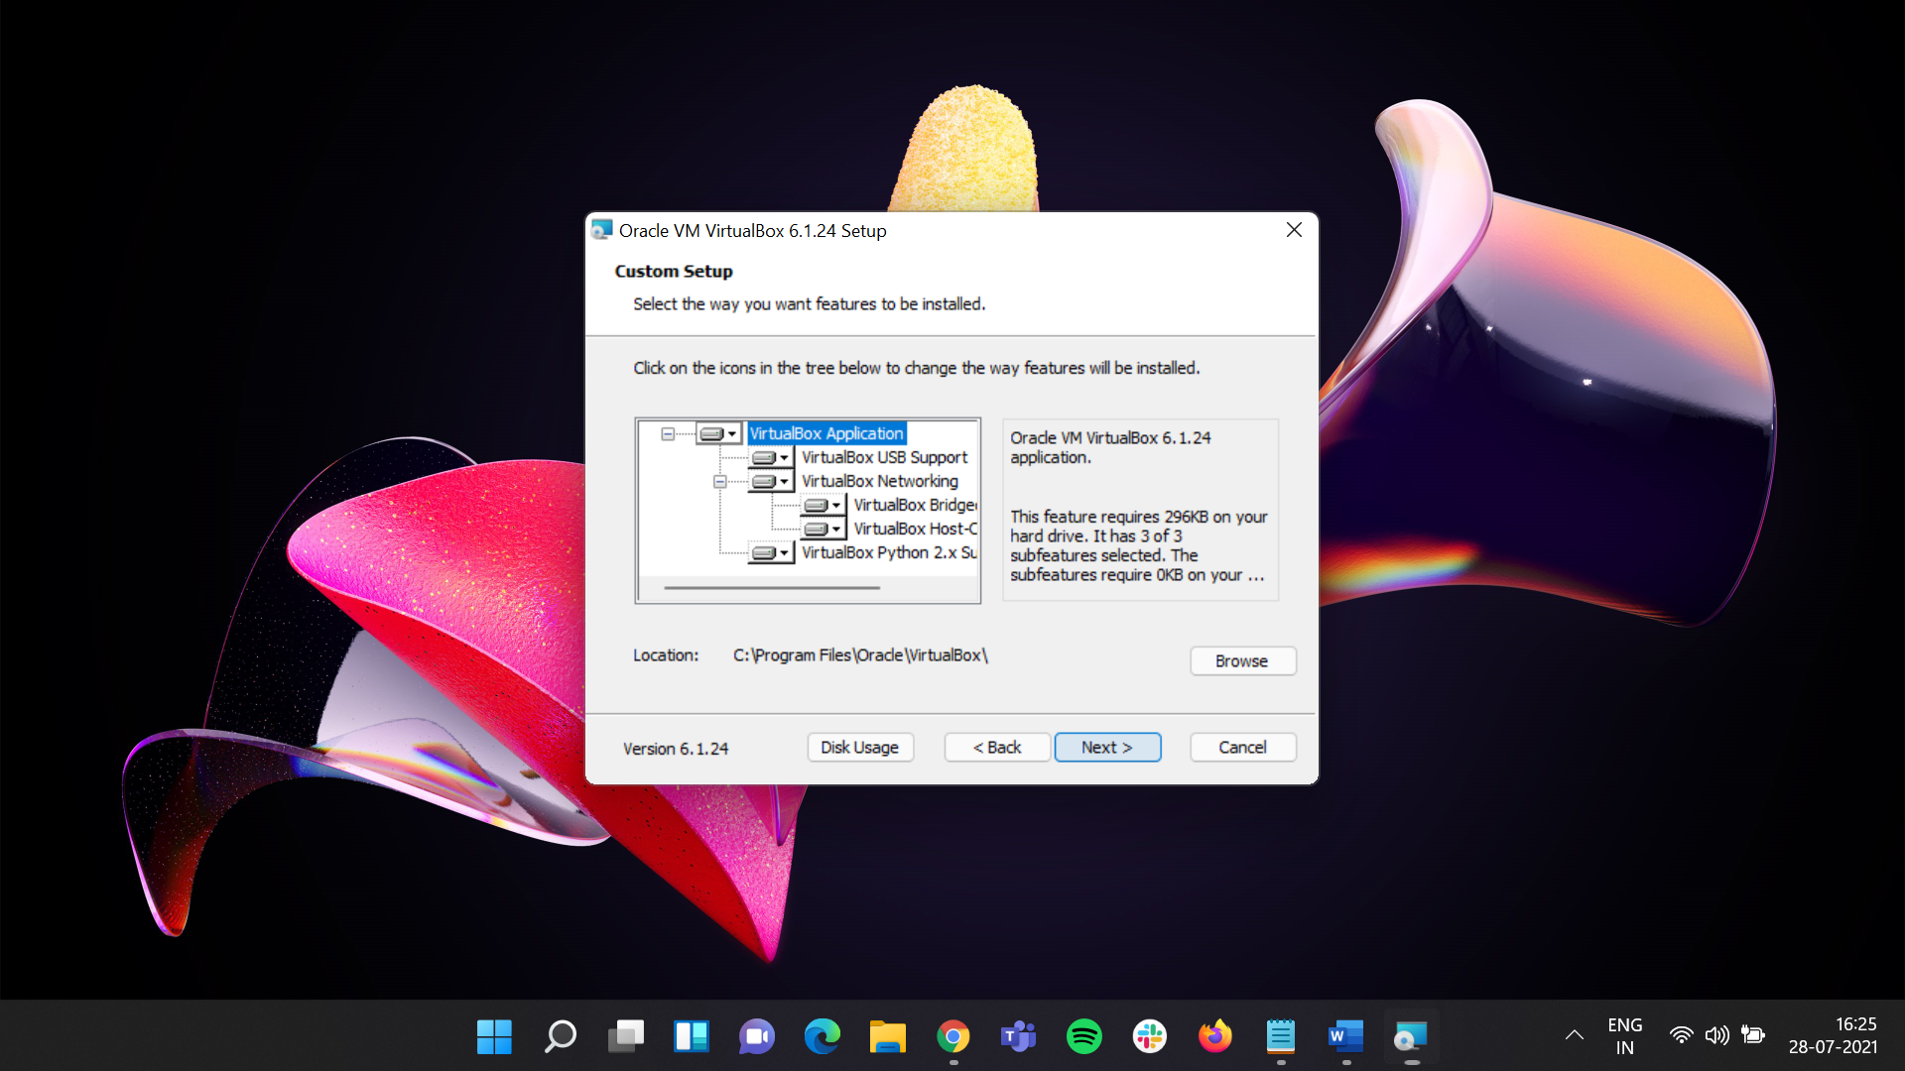

## Choose **Custom Setup** which you want or not if no change then click on **Next** button to proceed further.

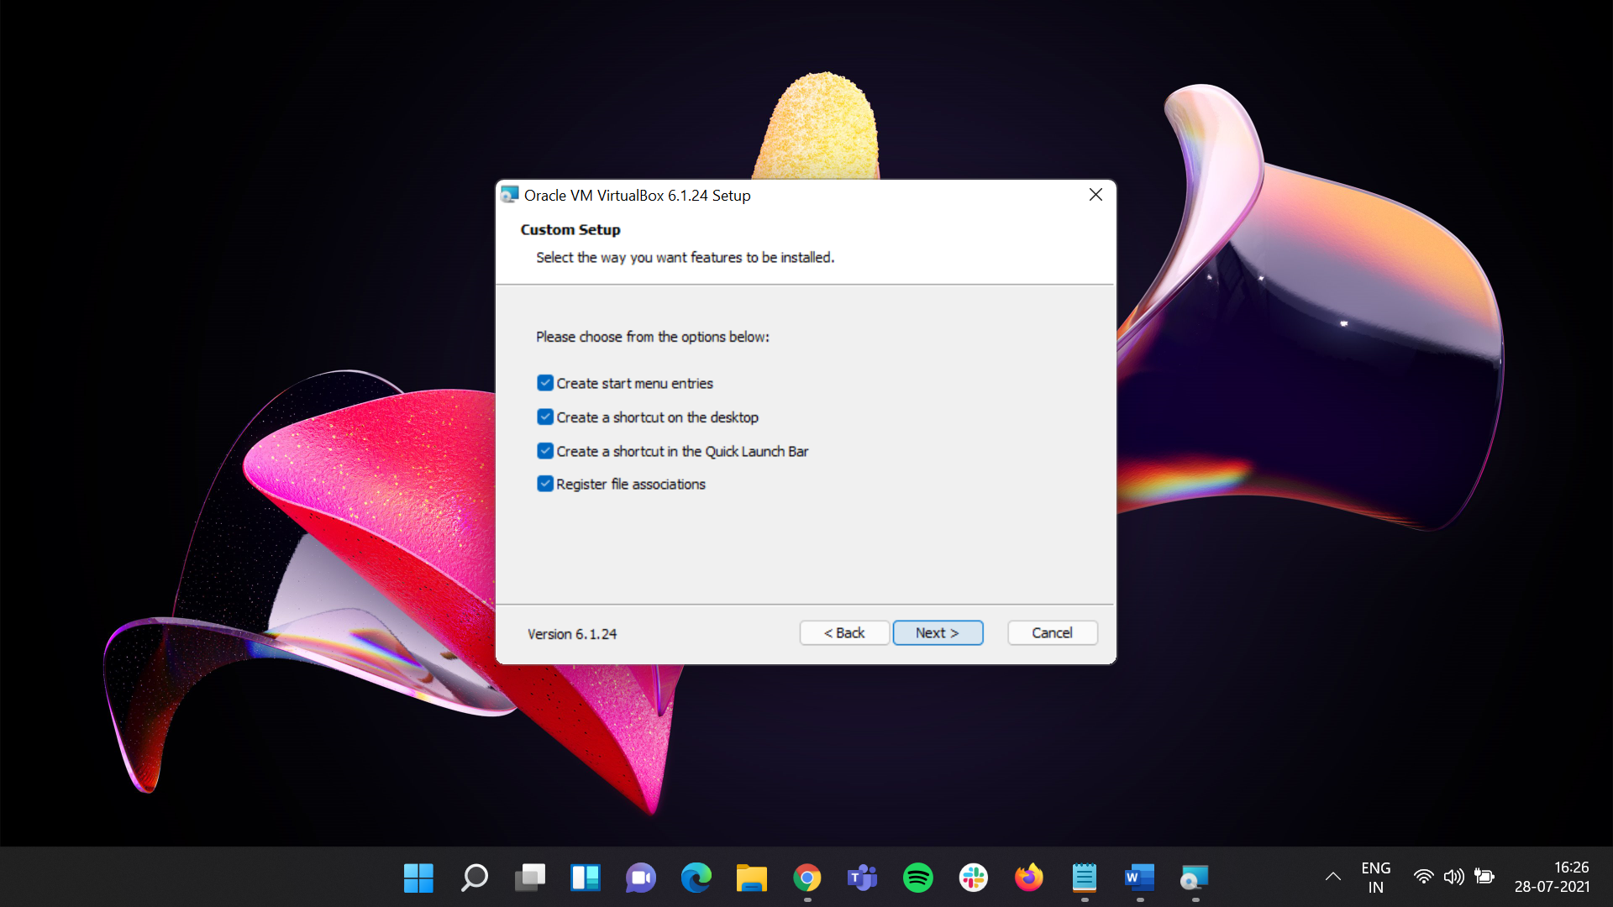

## It will show a W**arning** describing **Network Interfaces.** Ignore that and click on **Yes.**

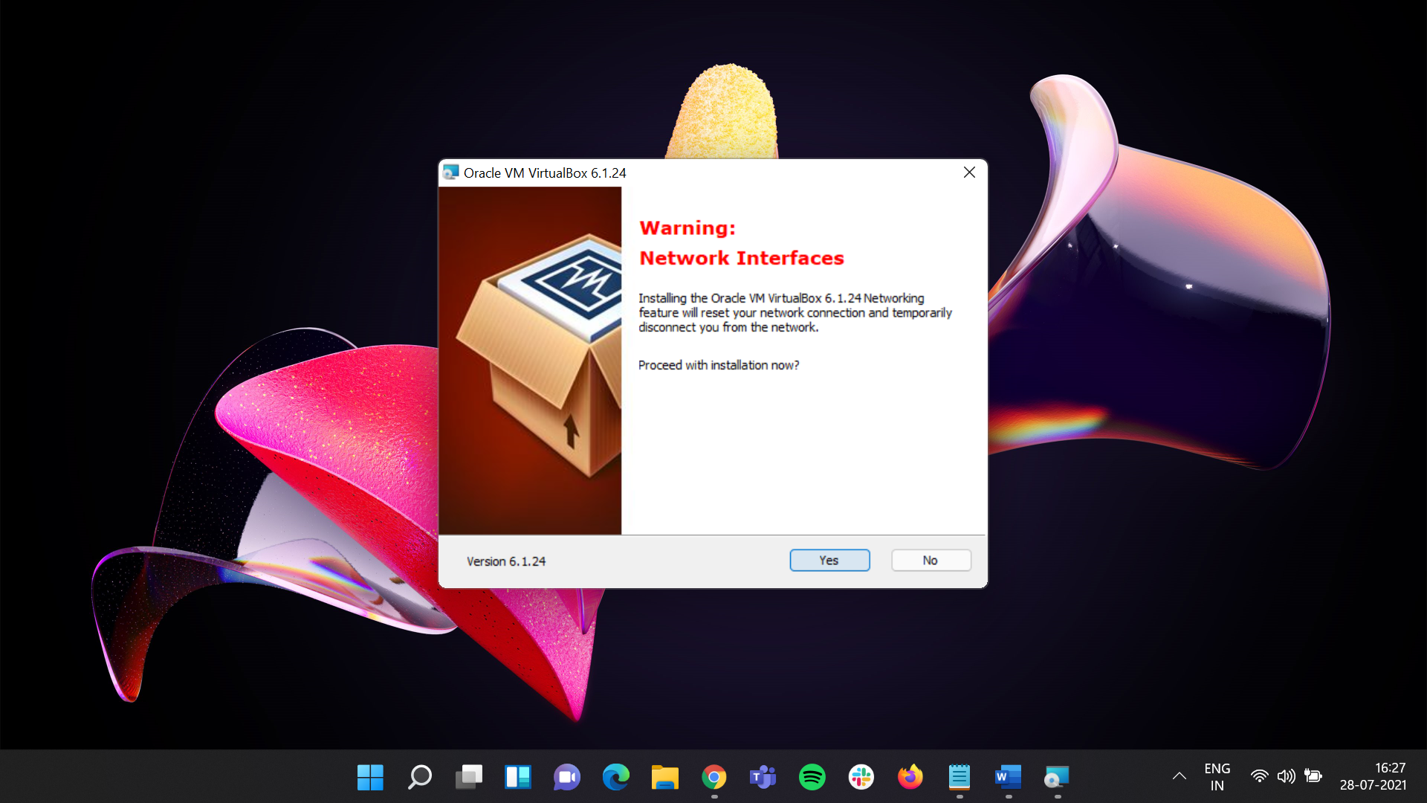

## It will show Ready to install window Click on **Install** to proceed further.

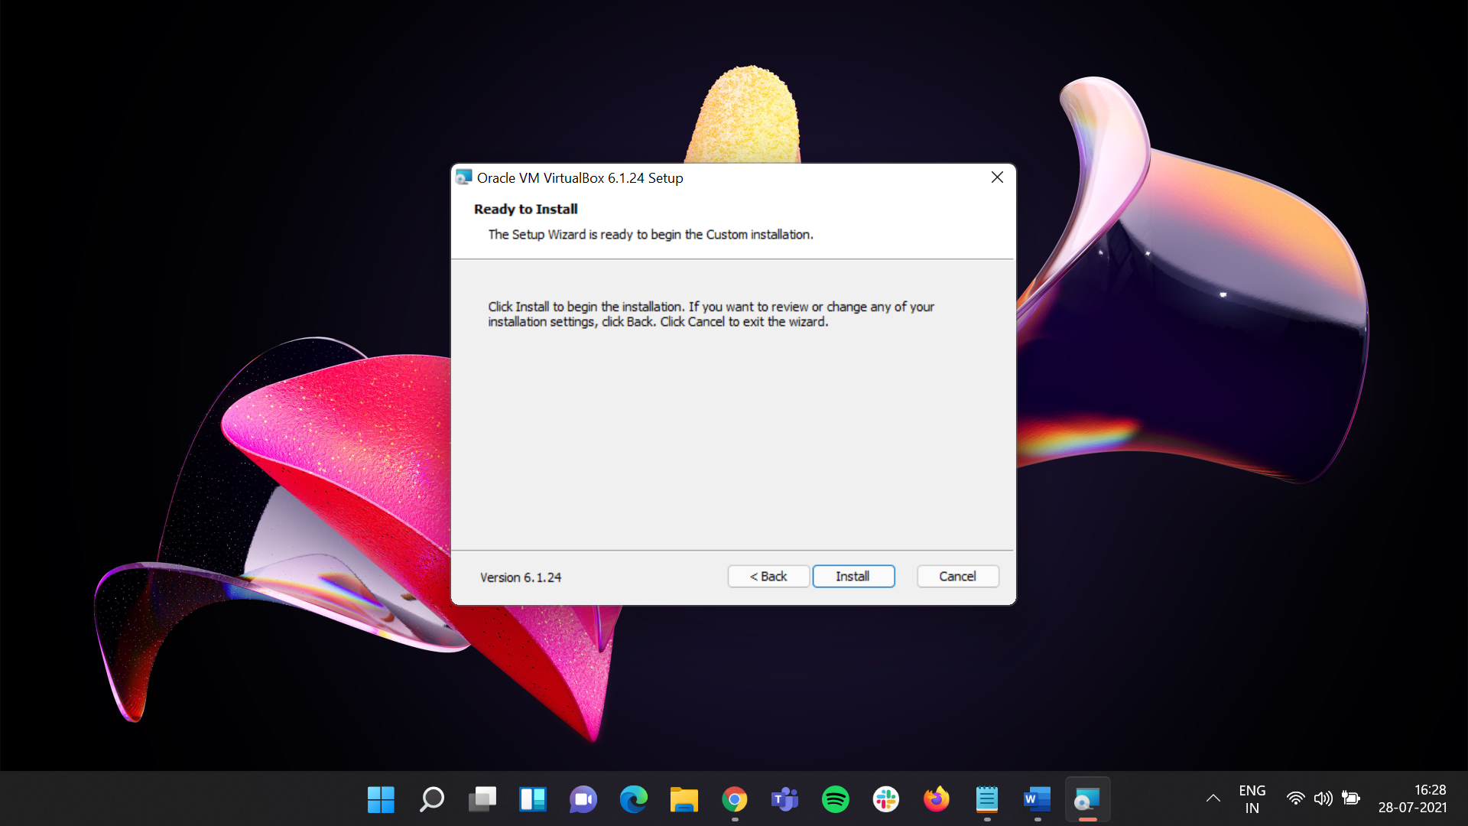

## The **Installation Process** will start up.

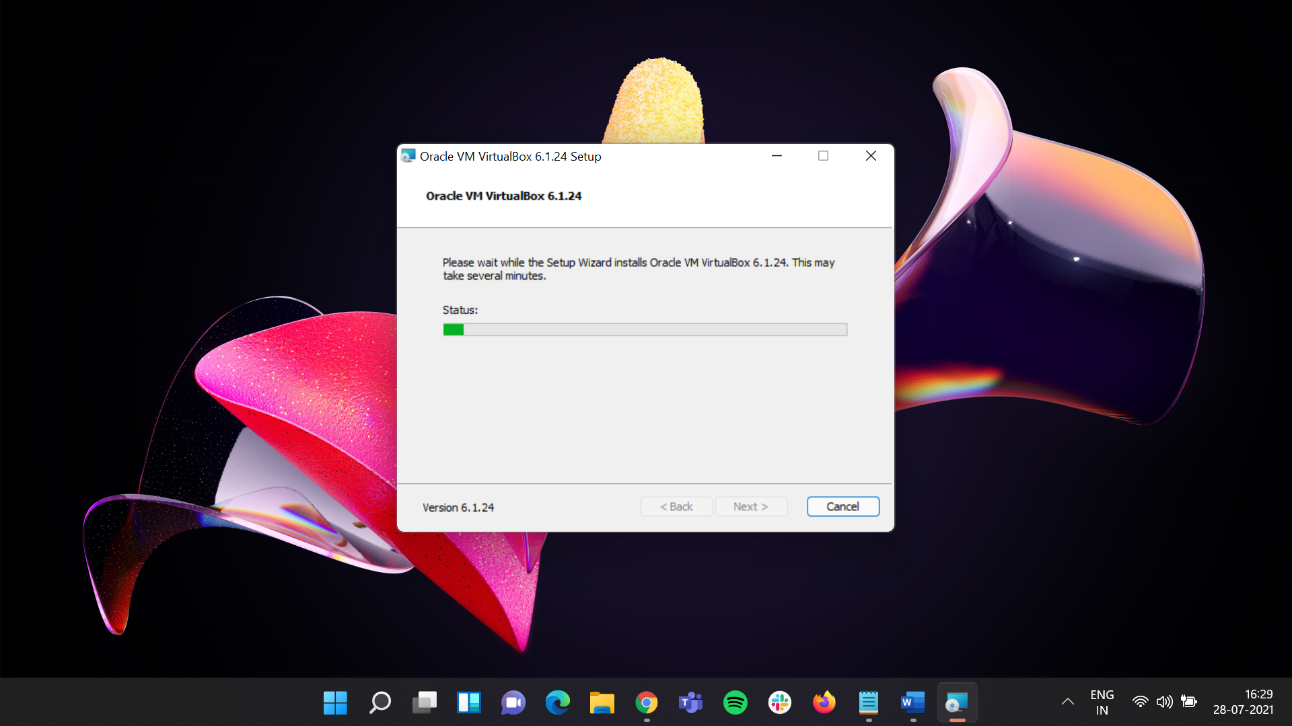

## Once Setup been done click on **Finish.**

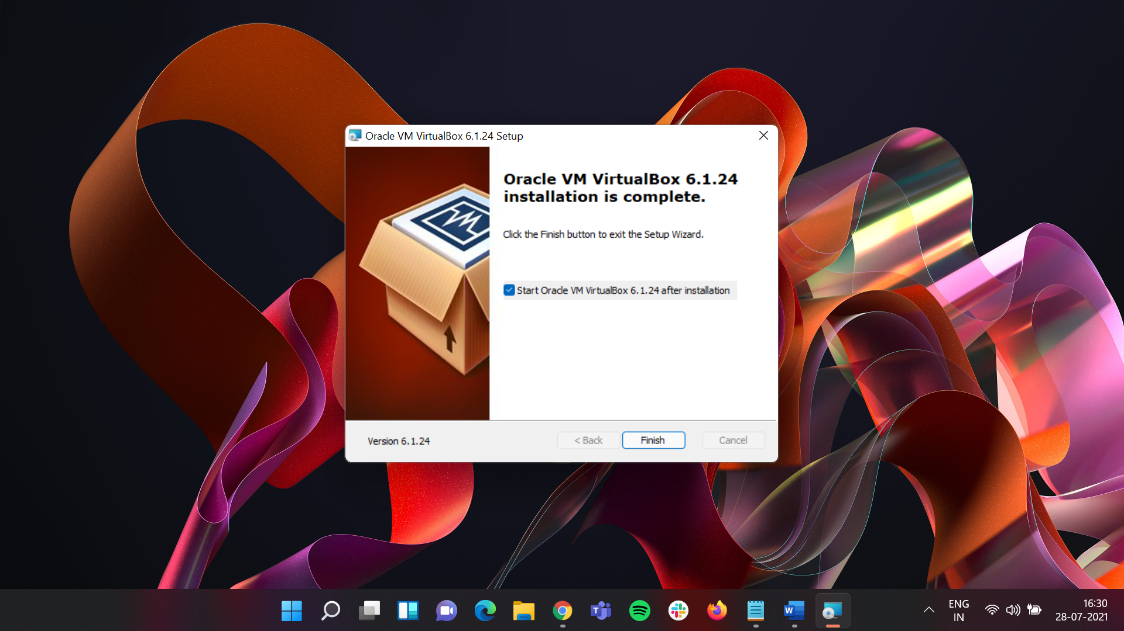

## A VM Icon will prompt in the taskbar with icon like this . Click on that and by doing that Oracle VM has been setup-ed in Windows 11.

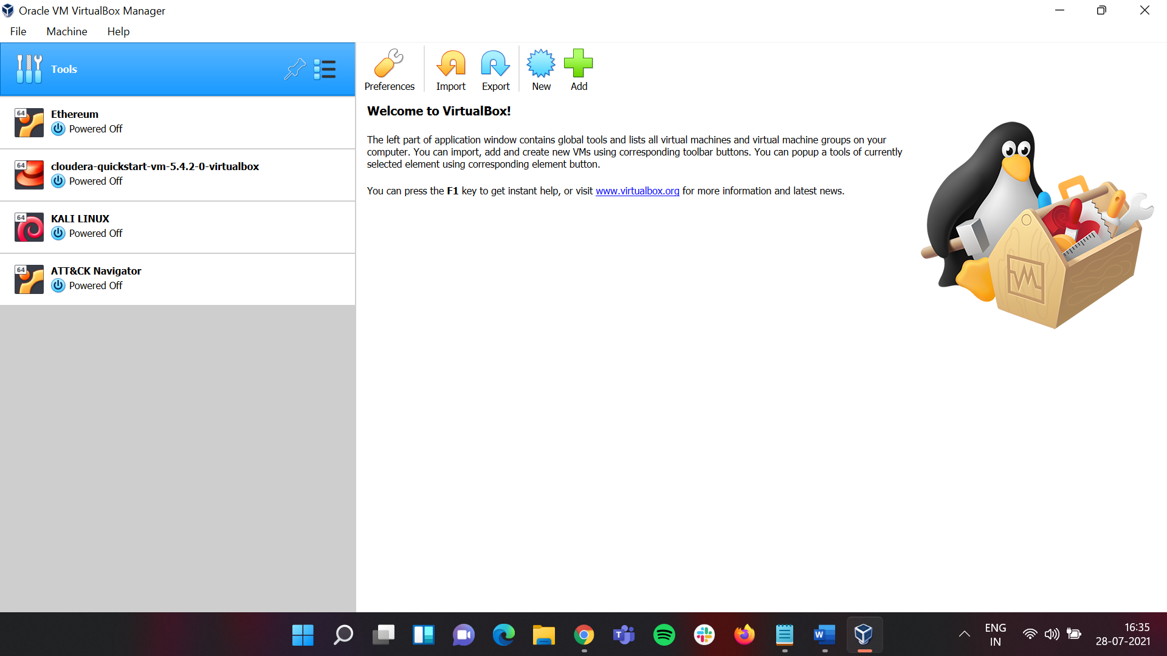

# Steps to install UBUNTU in Oracle Virtual Box/Machine

## Visit Oracle official Website Link: <https://ubuntu.com/download/desktop>

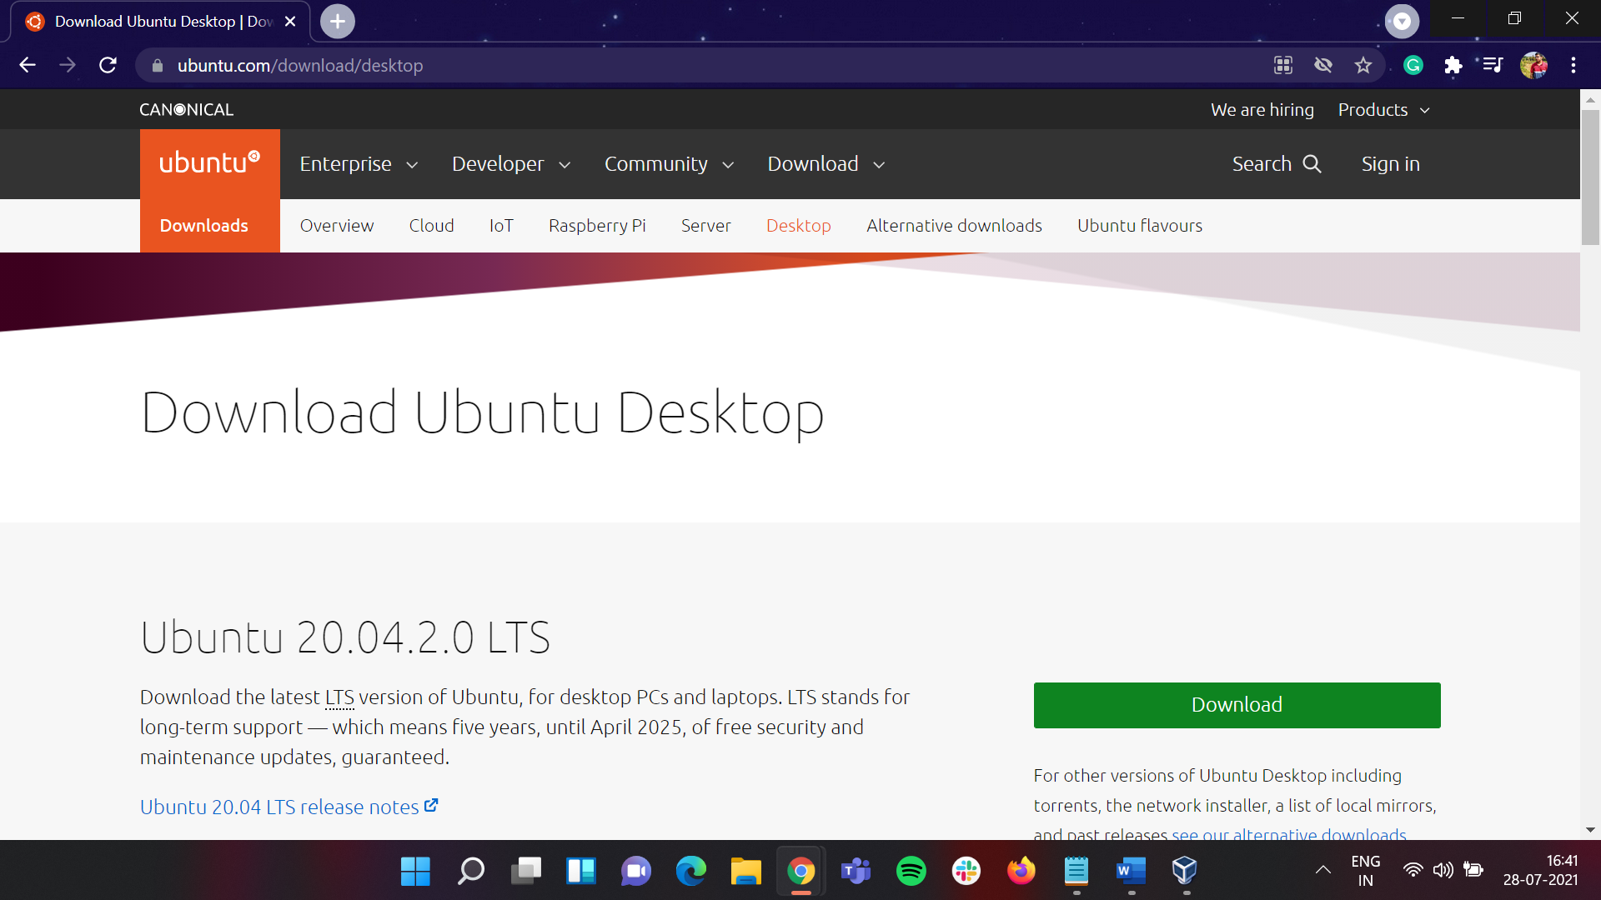

## Here we will be downloading **Ubuntu 20.04.2.0 LTS**. To download it faster I click on **see our alternative downloads** below **Download** icon corresponding to the version number.

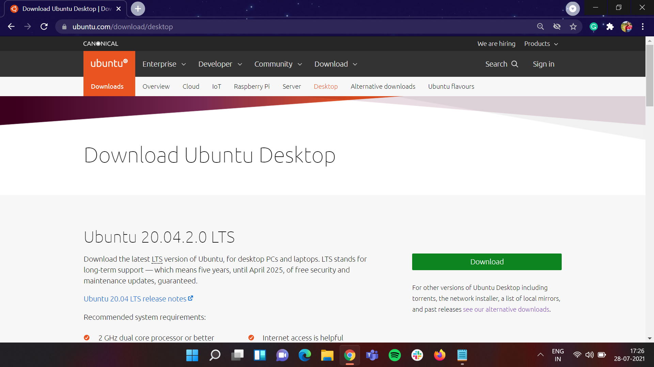

## Once clicking on that it will prompt to a new page showing alternative downloads

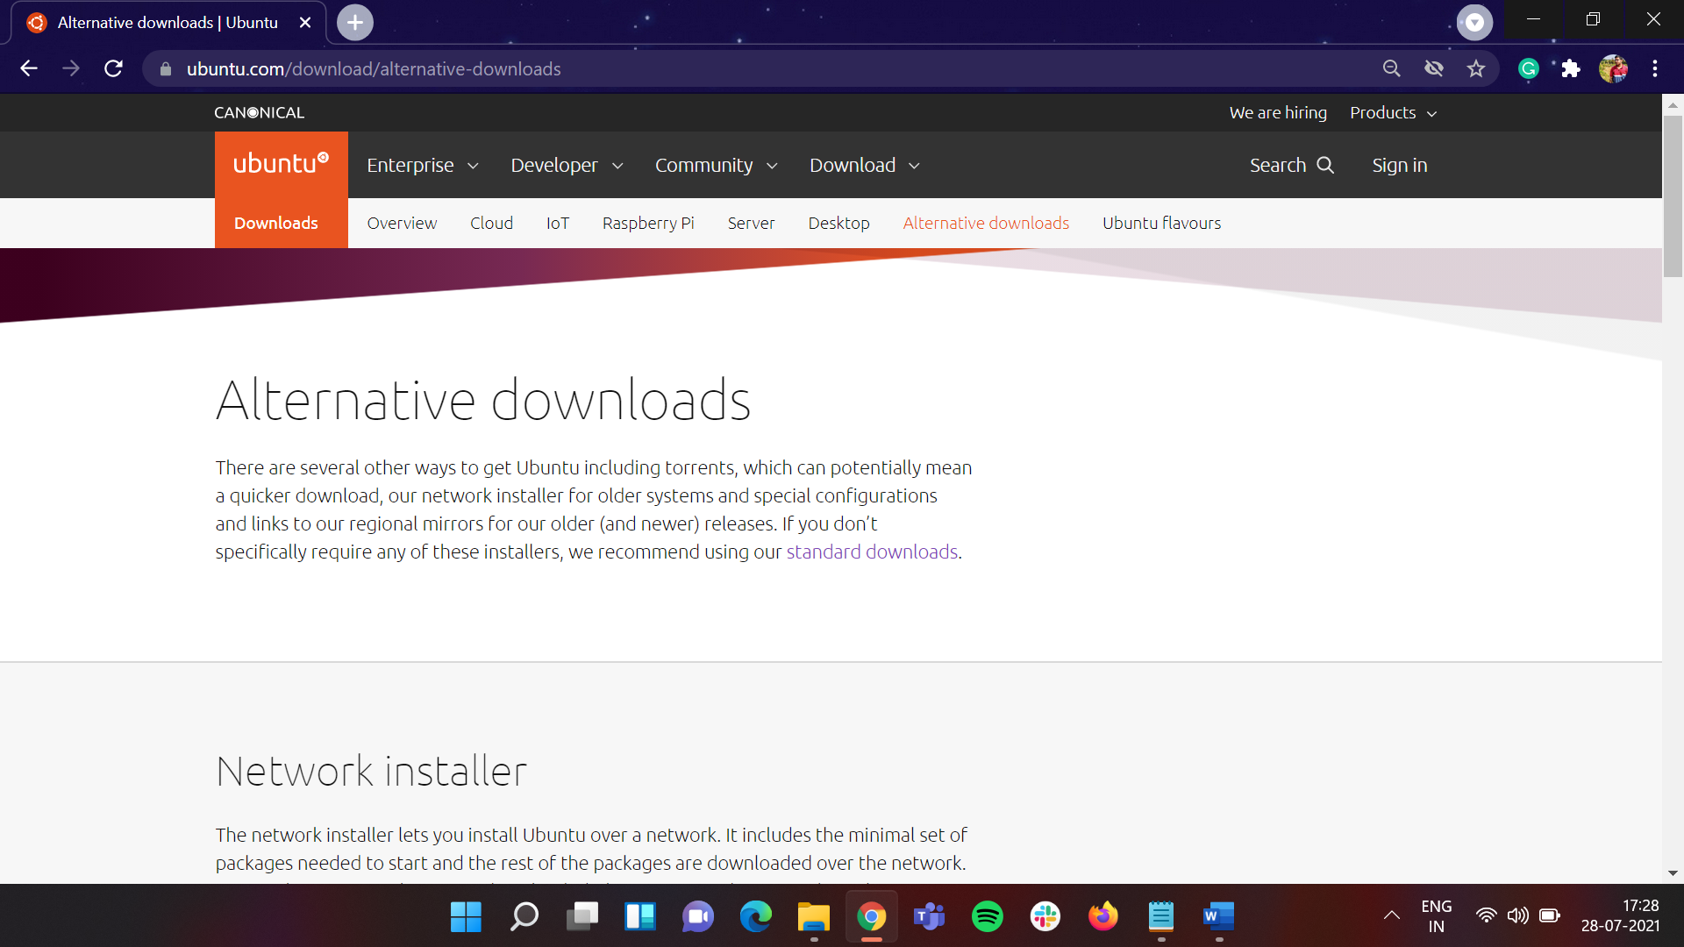

## Scroll down till you see BitTorrent as a topic

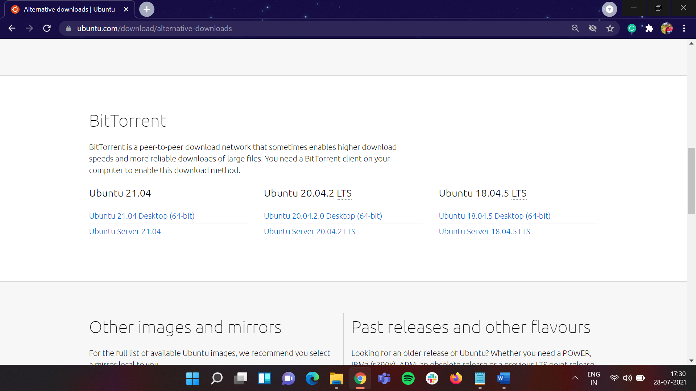

## Under **Ubuntu 20.04.2 LTS** click on **Ubuntu Server 20.04.2 Desktop (64-Bit)** and a torrent file will be downloaded click on that and wait till the download to complete.

### Torrent download link : <https://www.utorrent.com/>

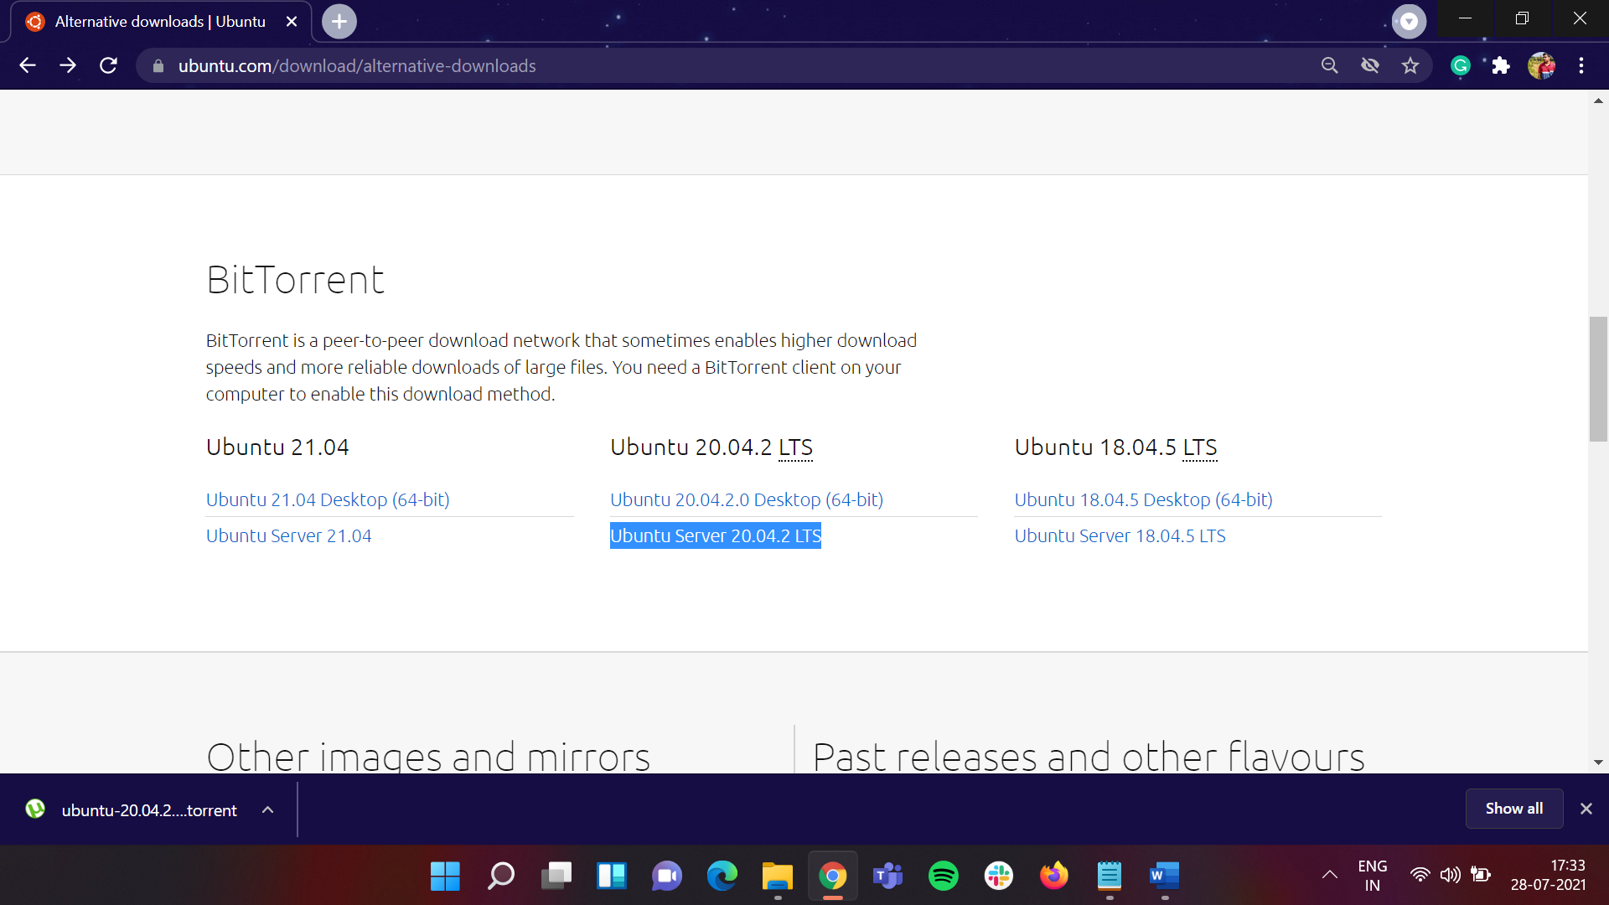

## On clicking the **downloaded torrent file**, it will prompt itself to **torrent website** and the download will proceed further.

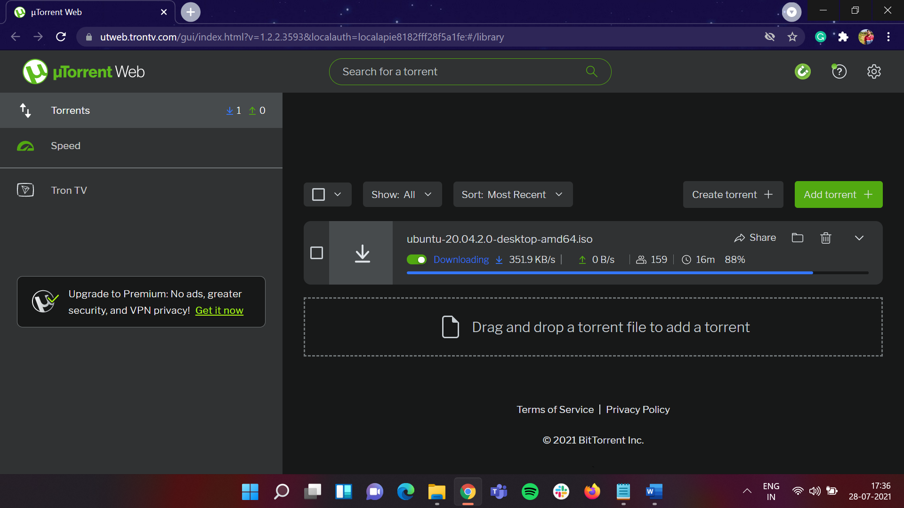

## Once download is completed open the Oracle VM

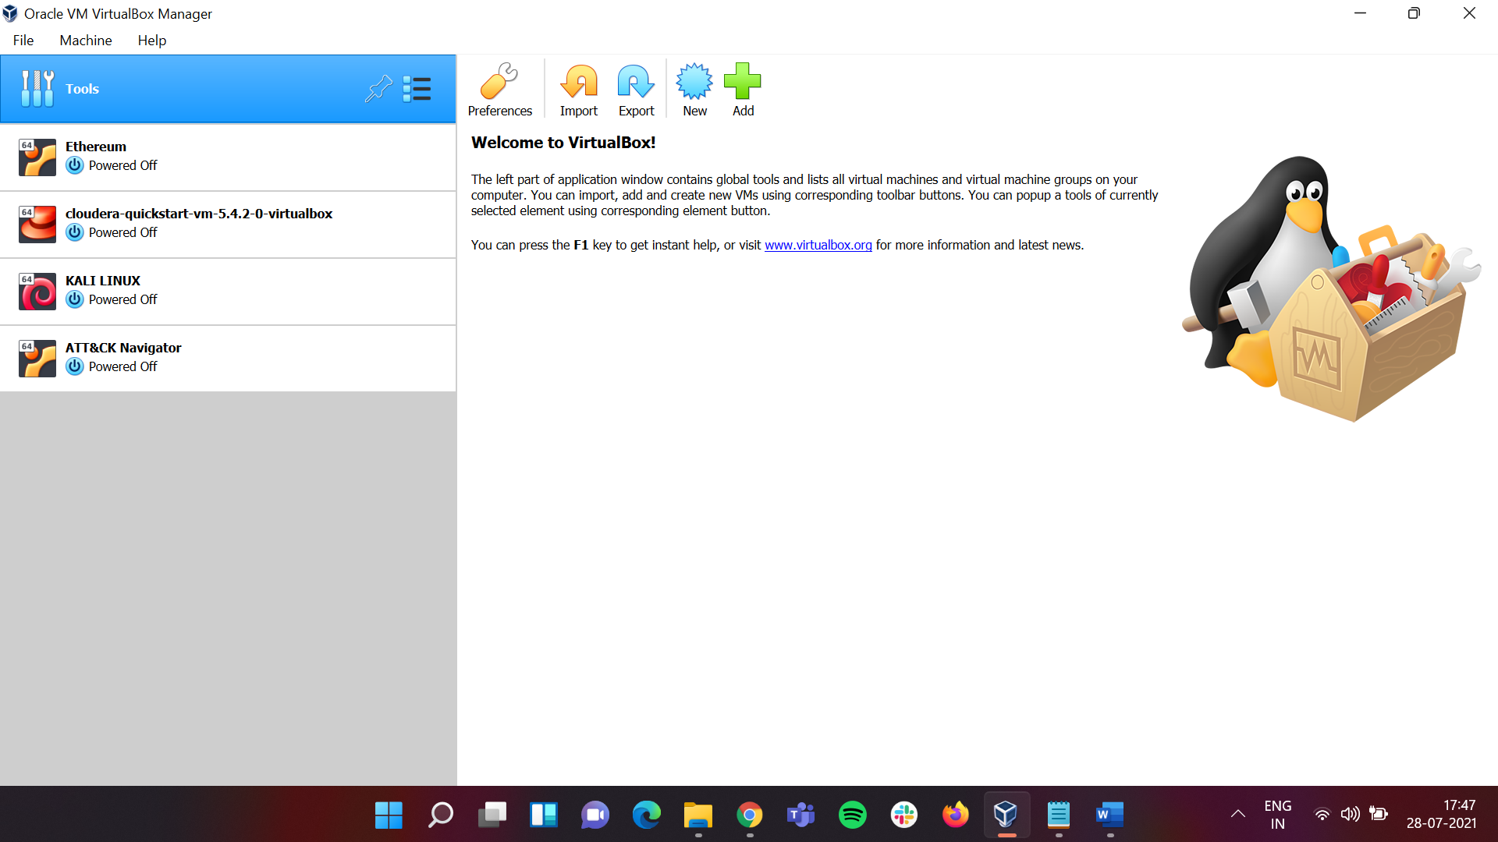

## Under **Tools** click on **New**

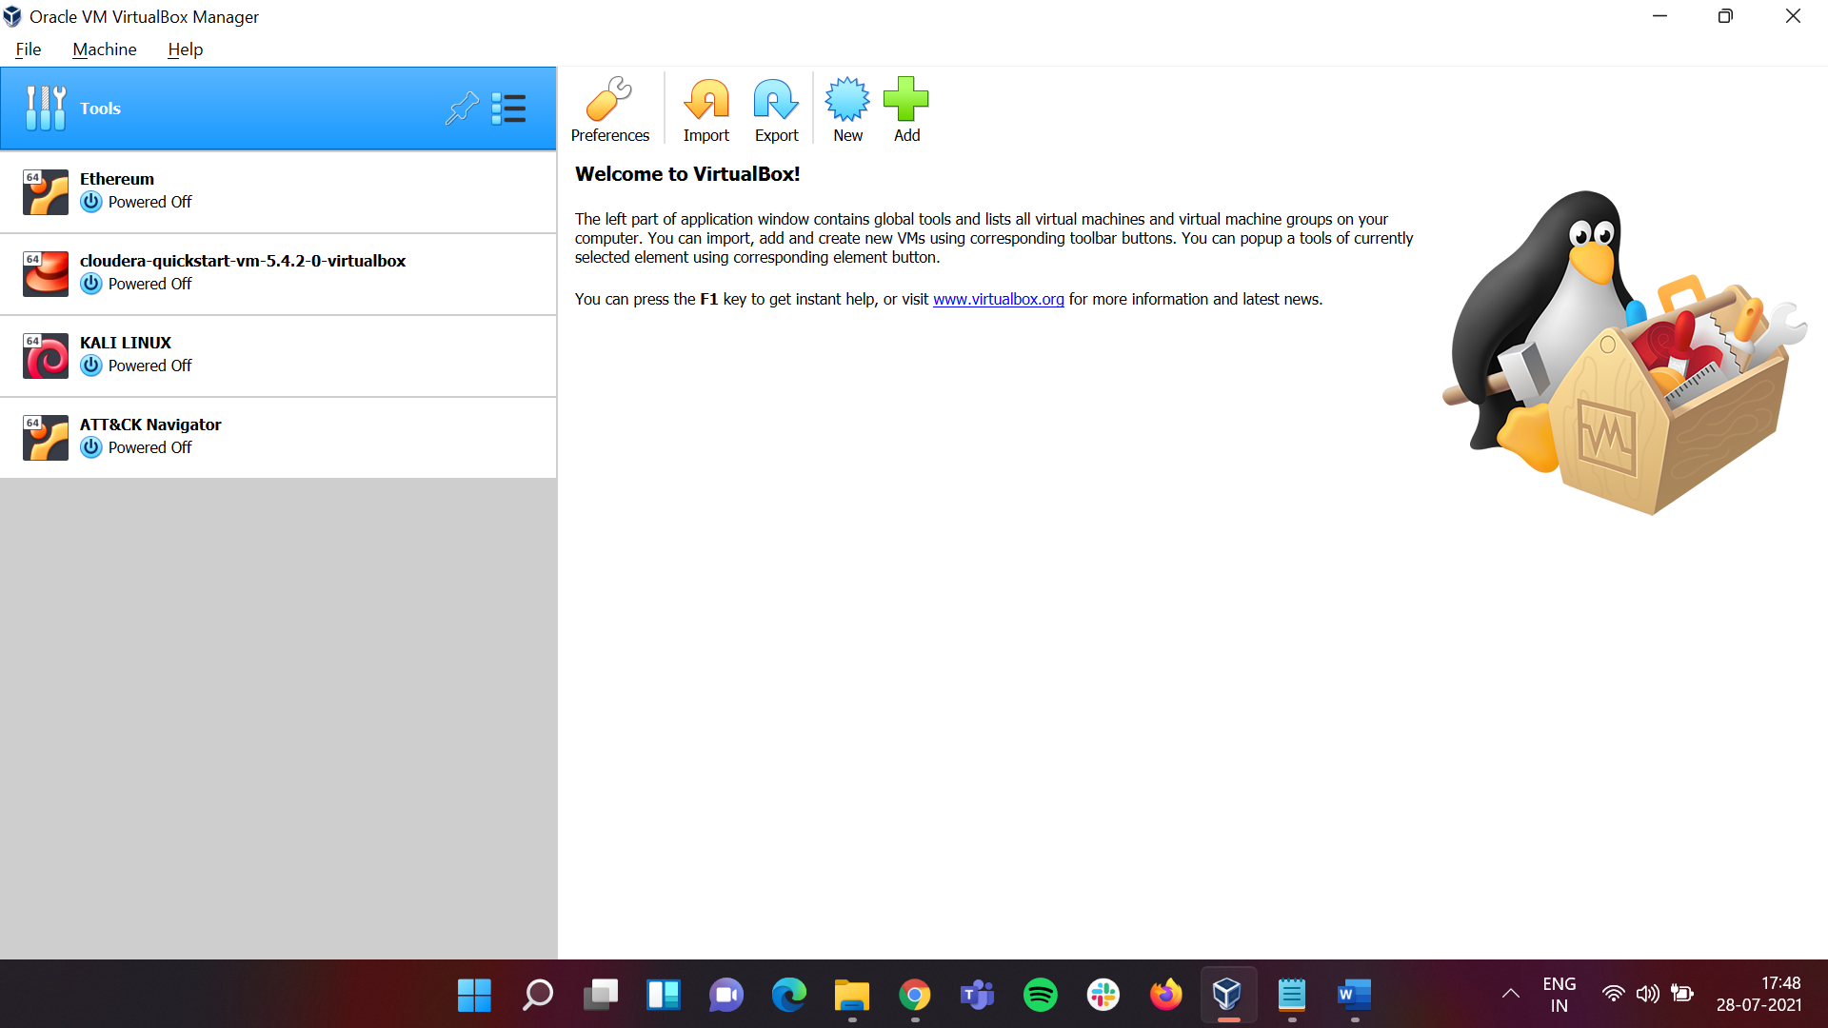

## In **Name and Operating System** Sub-window under **Name**, name it as “**Ubuntu**”. And click on **Next.**

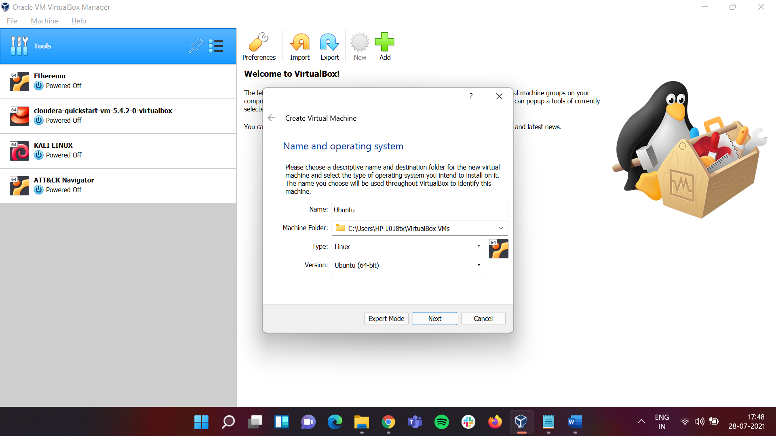

## In **Memory Size** Sub-window set the memory size up to the **green bar** which in my case will be at **5265 MB**. After doing that click on **Next.**

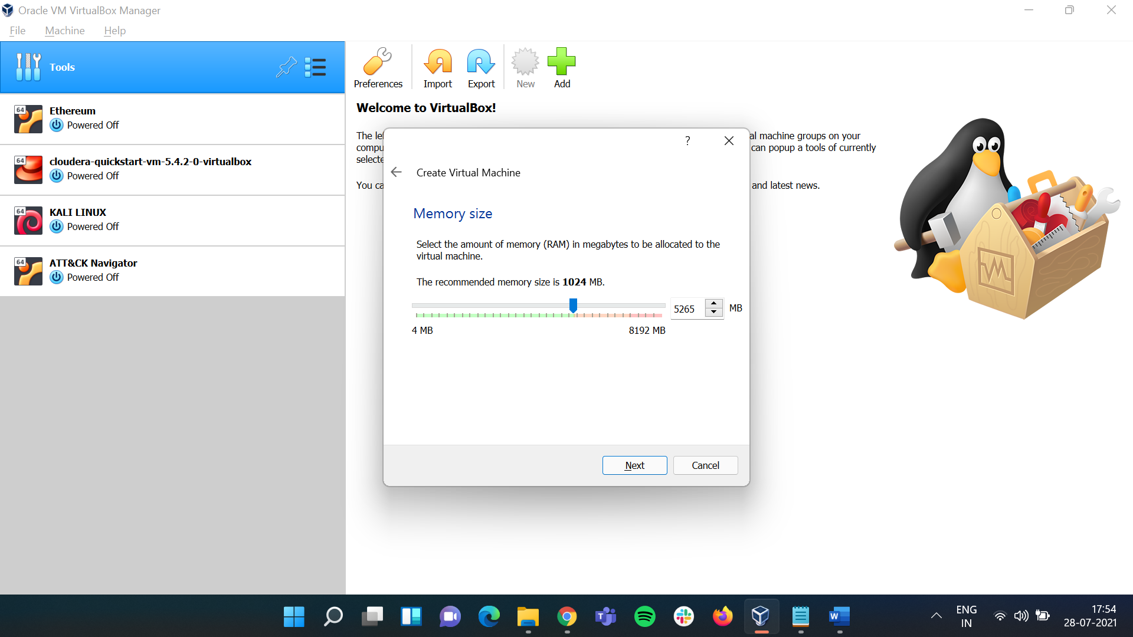

## Under **Hard Disk** Sub-window leave it as default and click on **Create.**

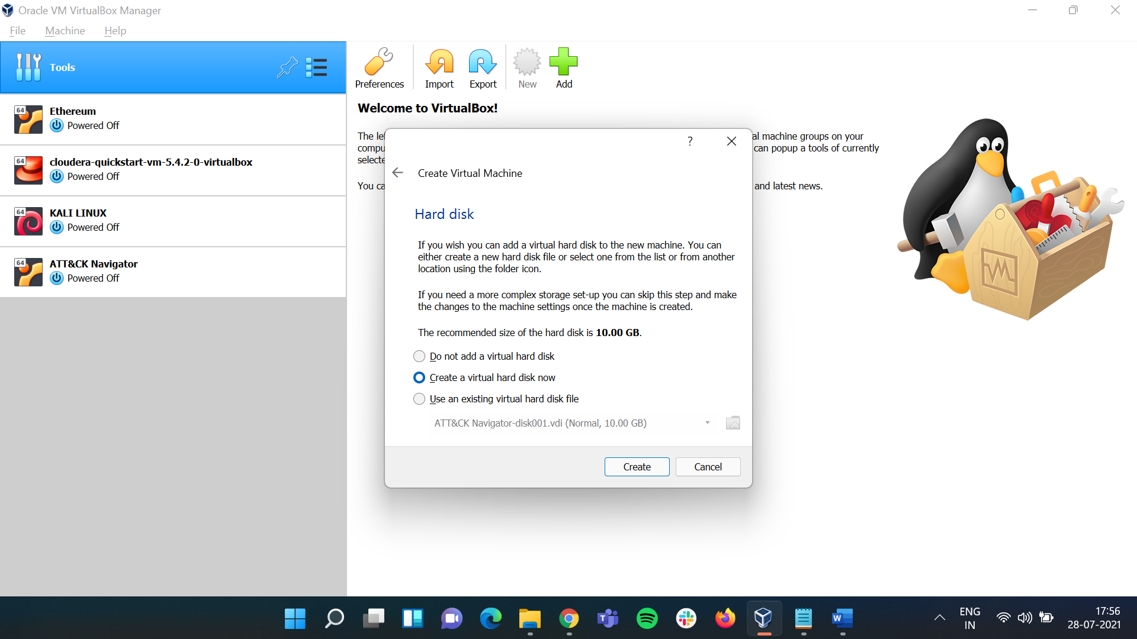

## Under **Hard Disk File Type** Sub-windowclick on **VDI (Virtual Disk Image).** After that click on **Next.**

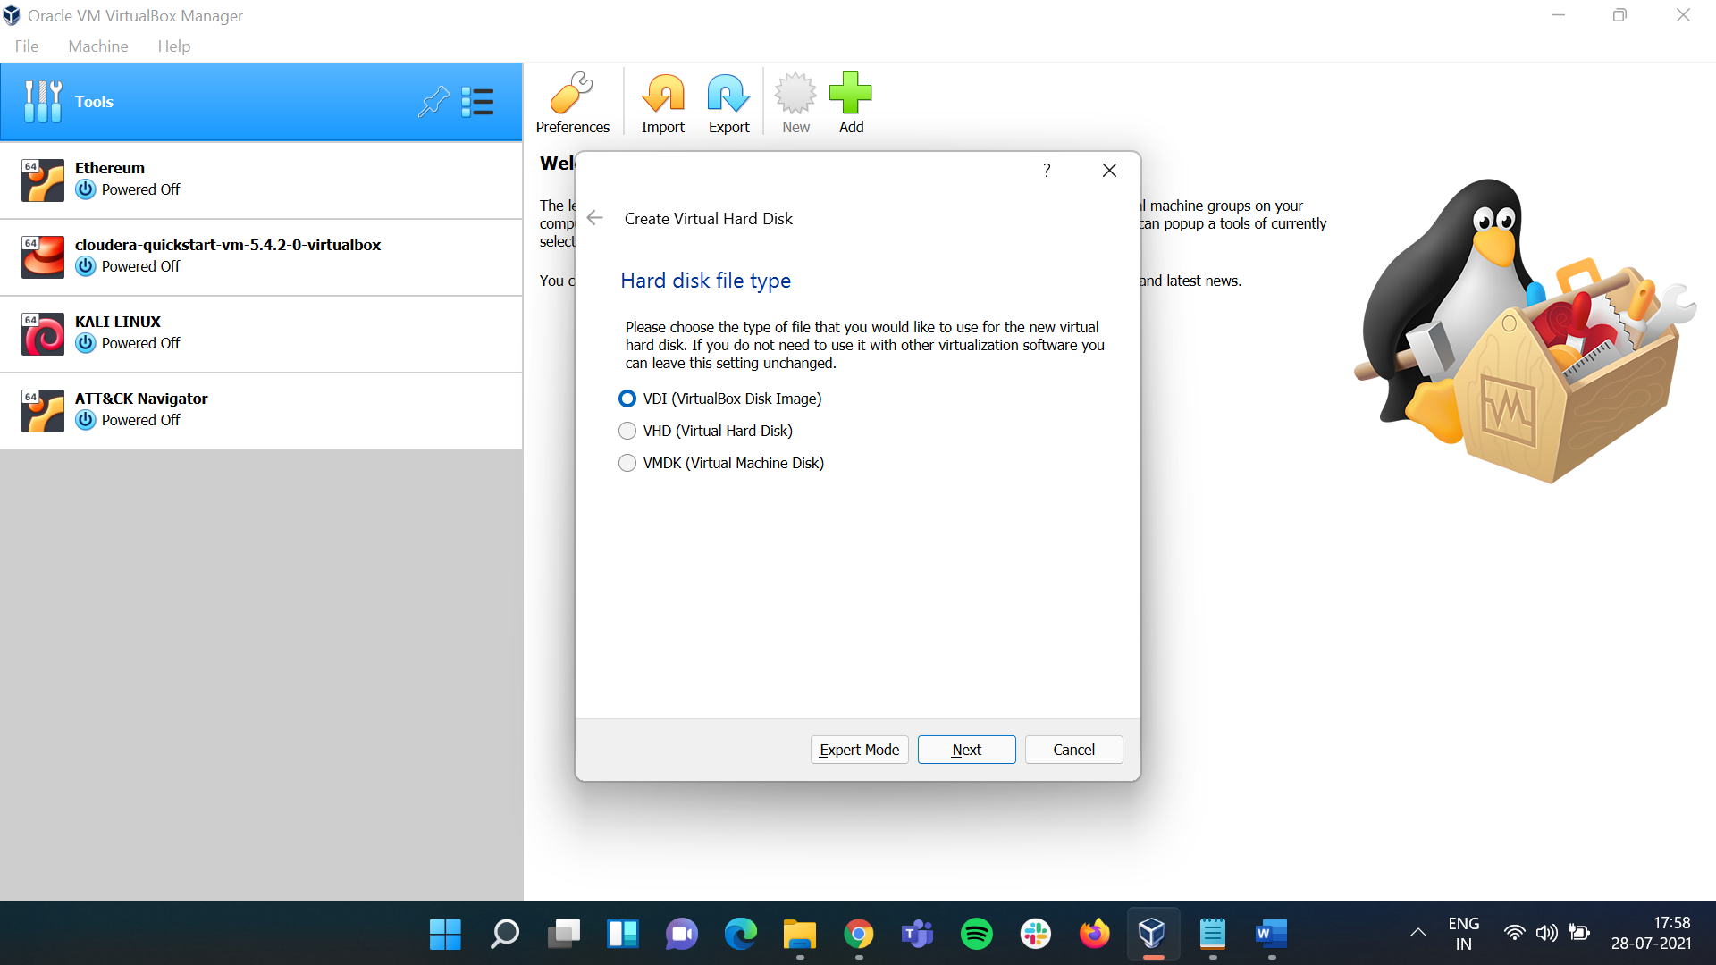

## Under **Storage on physical Hard Disk** Sub-Window click on **Dynamically Allocated**. After that click on **Next.**

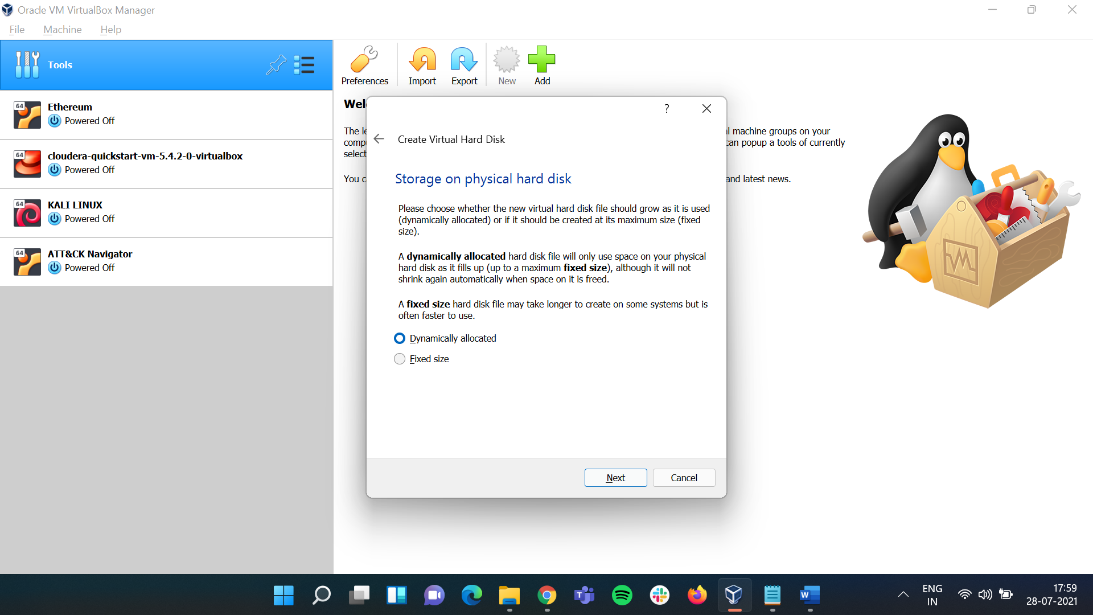

## We are now at the last step. In the **File location and Size** Sub-Window change the **memory size** to **100.00 GB.** After that click on **Create.**

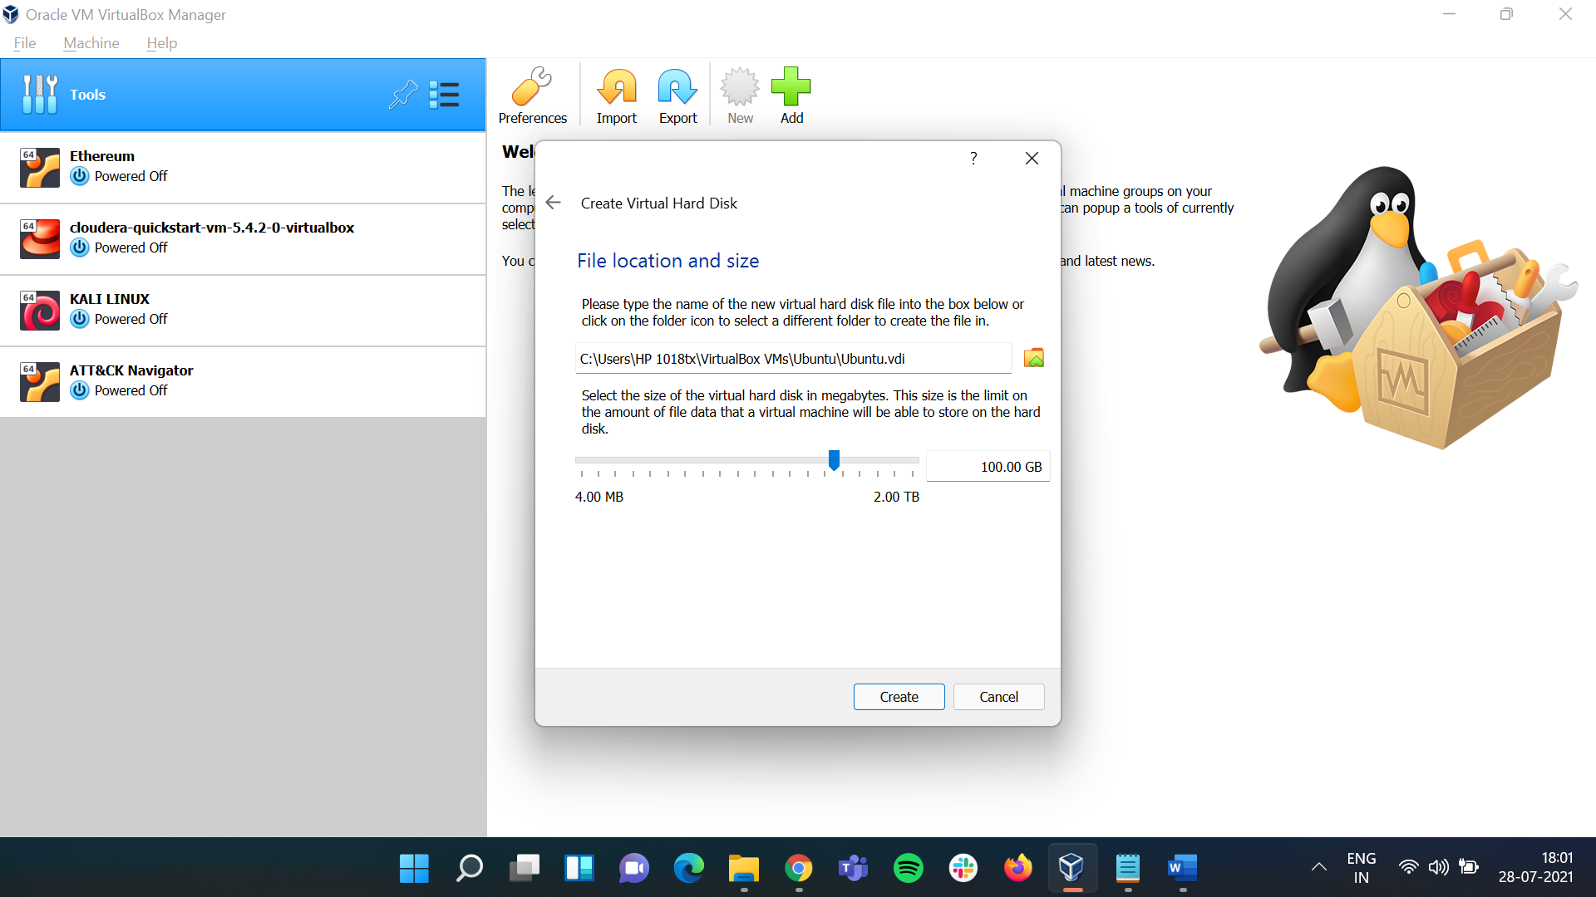

## Now **Ubuntu** has been added to **Oracle VM**.

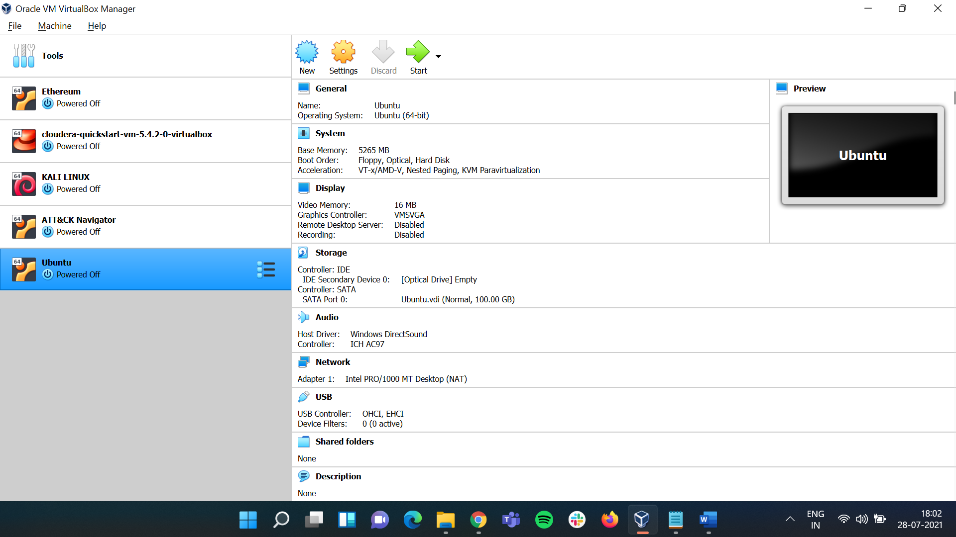

## Here click on **Settings**

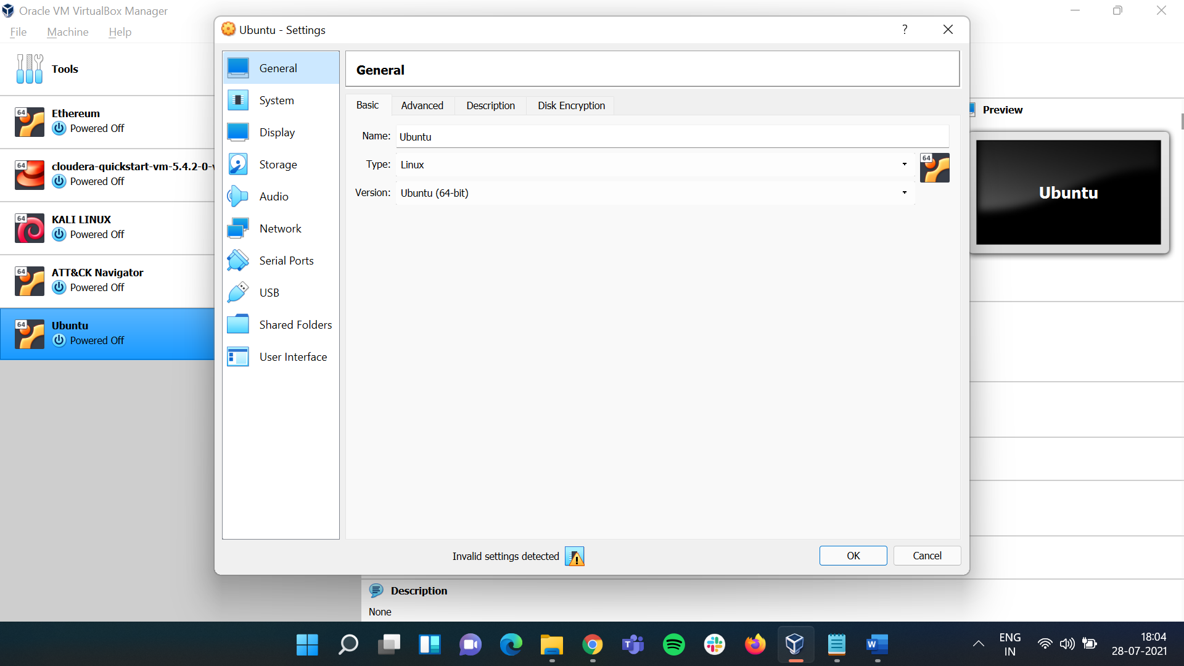

## On the **Settings** Sub-window under

### **General** click on **Advanced** and change **Shared Clipboard Drag'n'Drop** from **Disabled** to **Bidirectional**.

### **System** click on **Processor** and change **Processor(s)** from **1 CPU** to **4 CPU.**

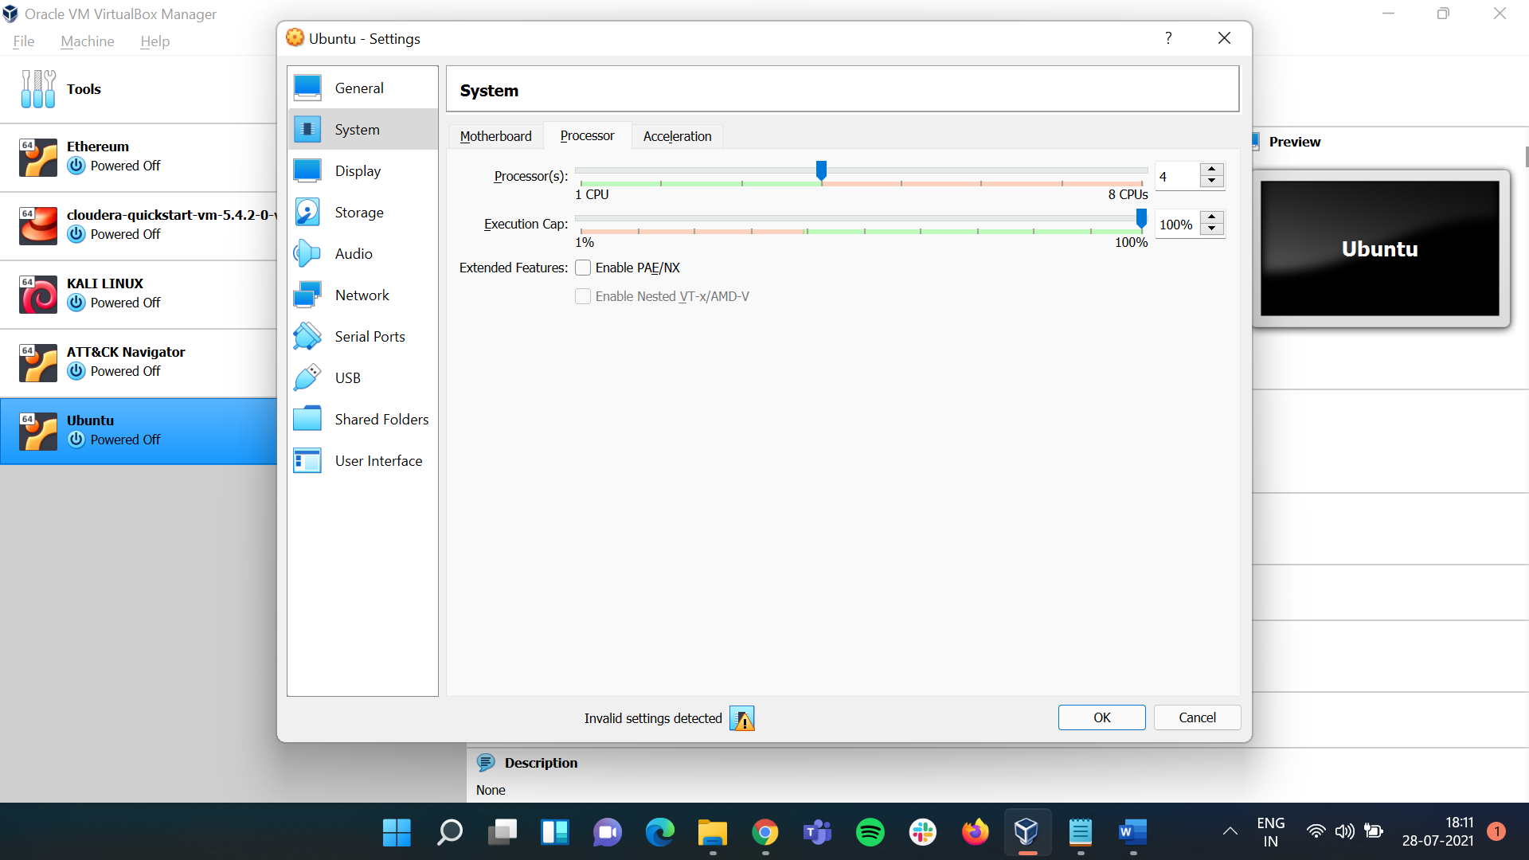

### **Display** leave it as default

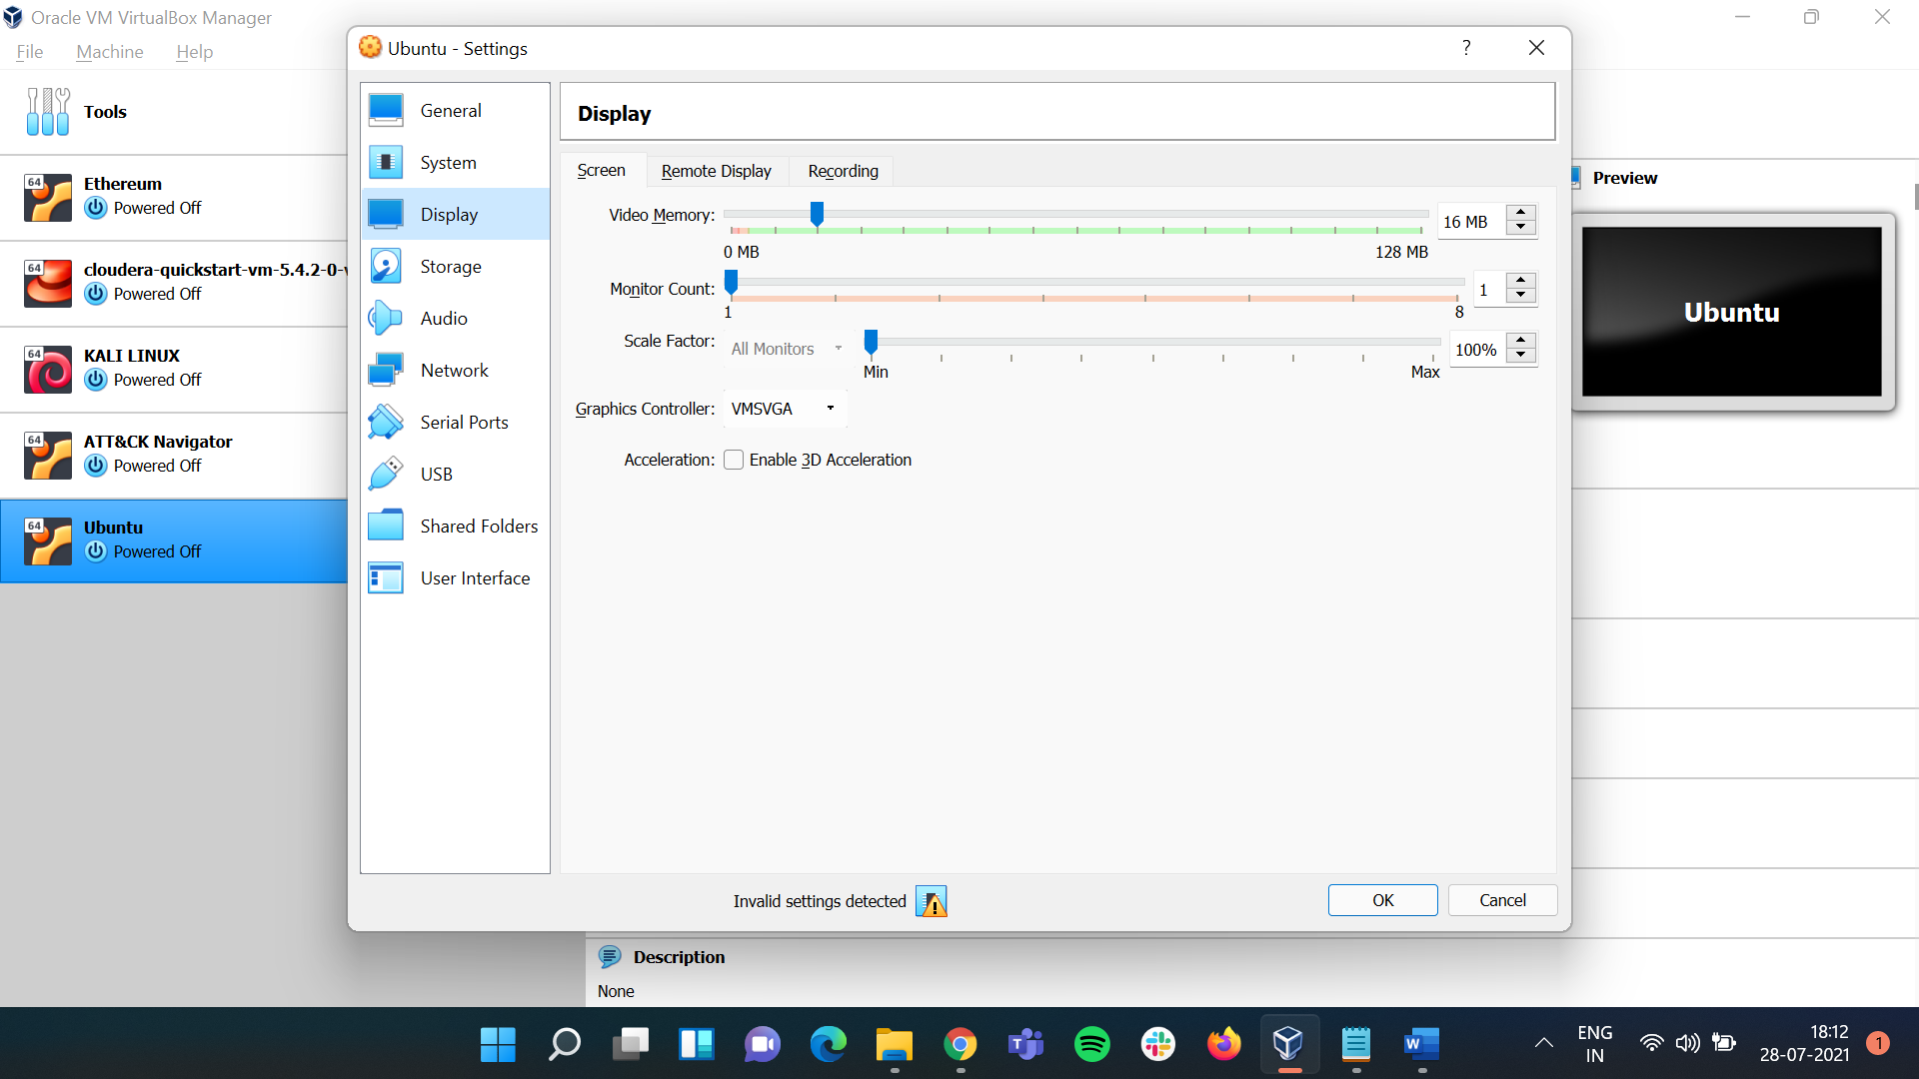

### **Storage** click on **Controller : IDE – Empty** here we have to add the **ISO** file we downloaded for that click on **the disk icon** then on **Choose a disk file** and choose the ISO file

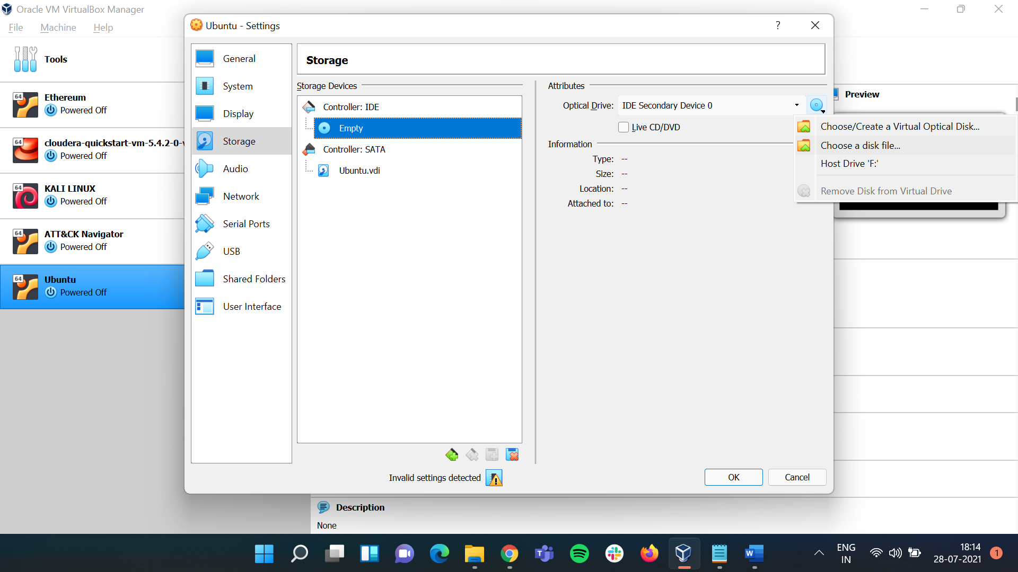 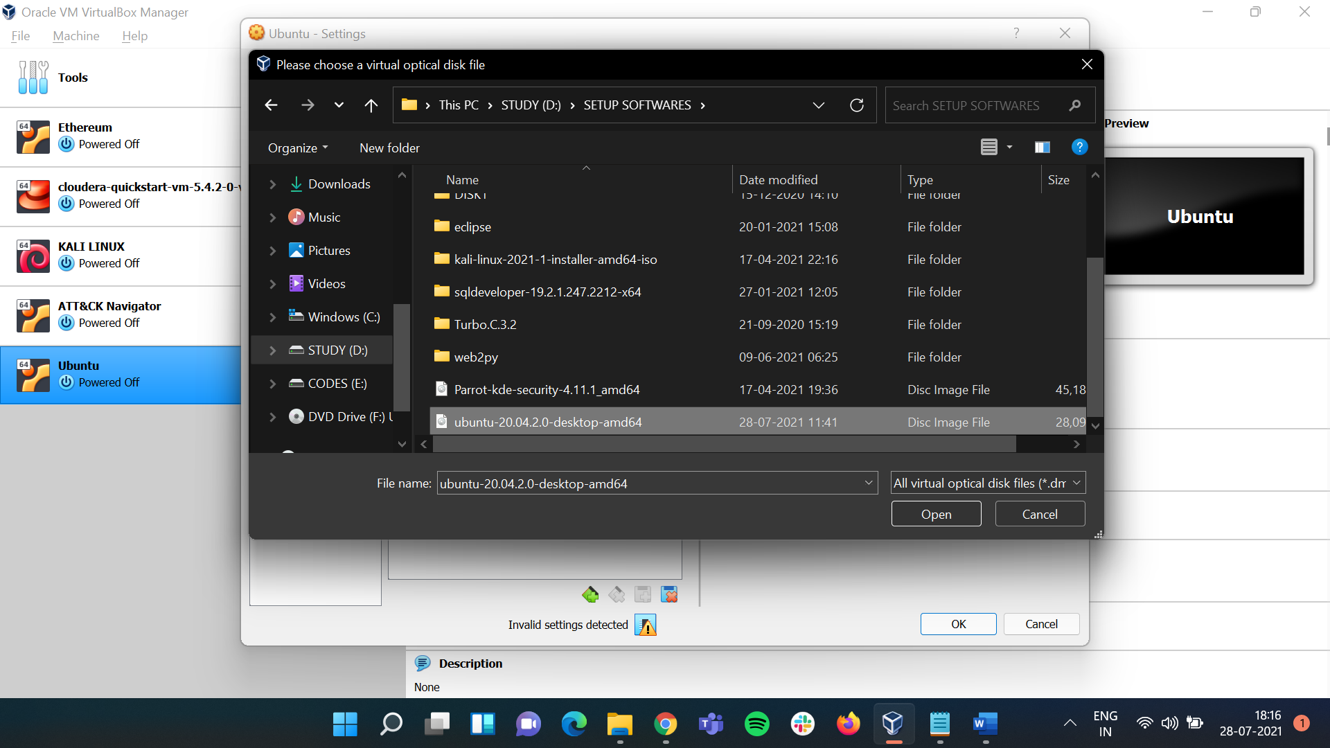

### Once added click on **Ok** and then the main page will open.

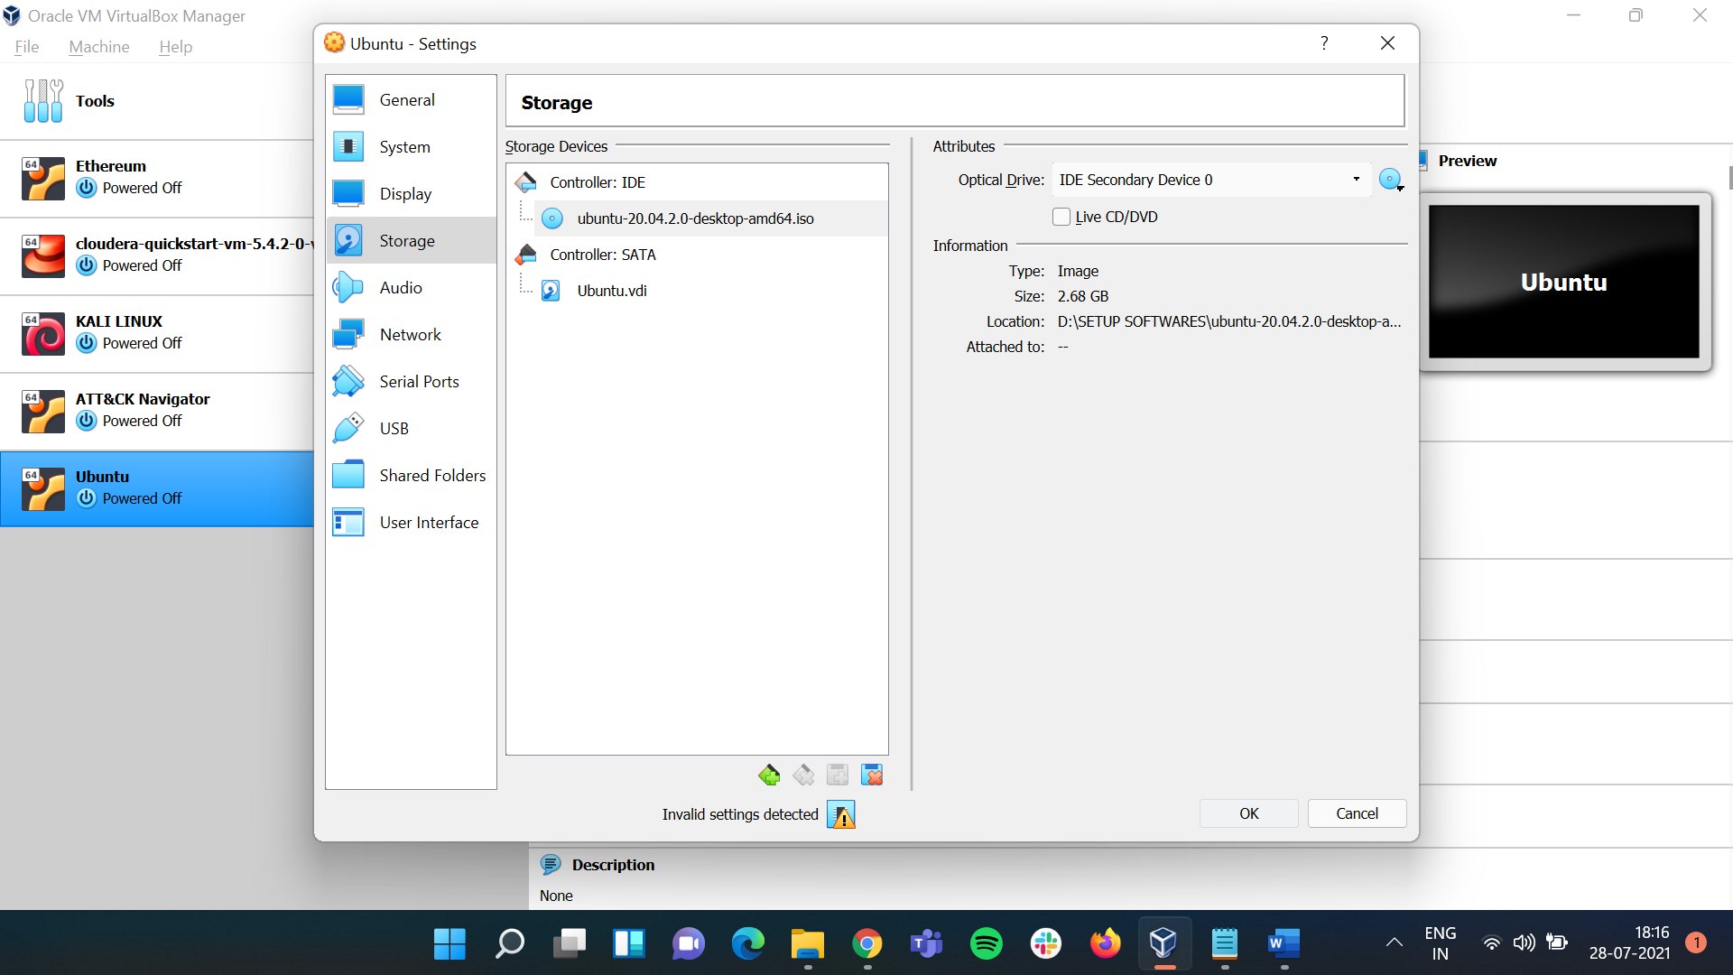 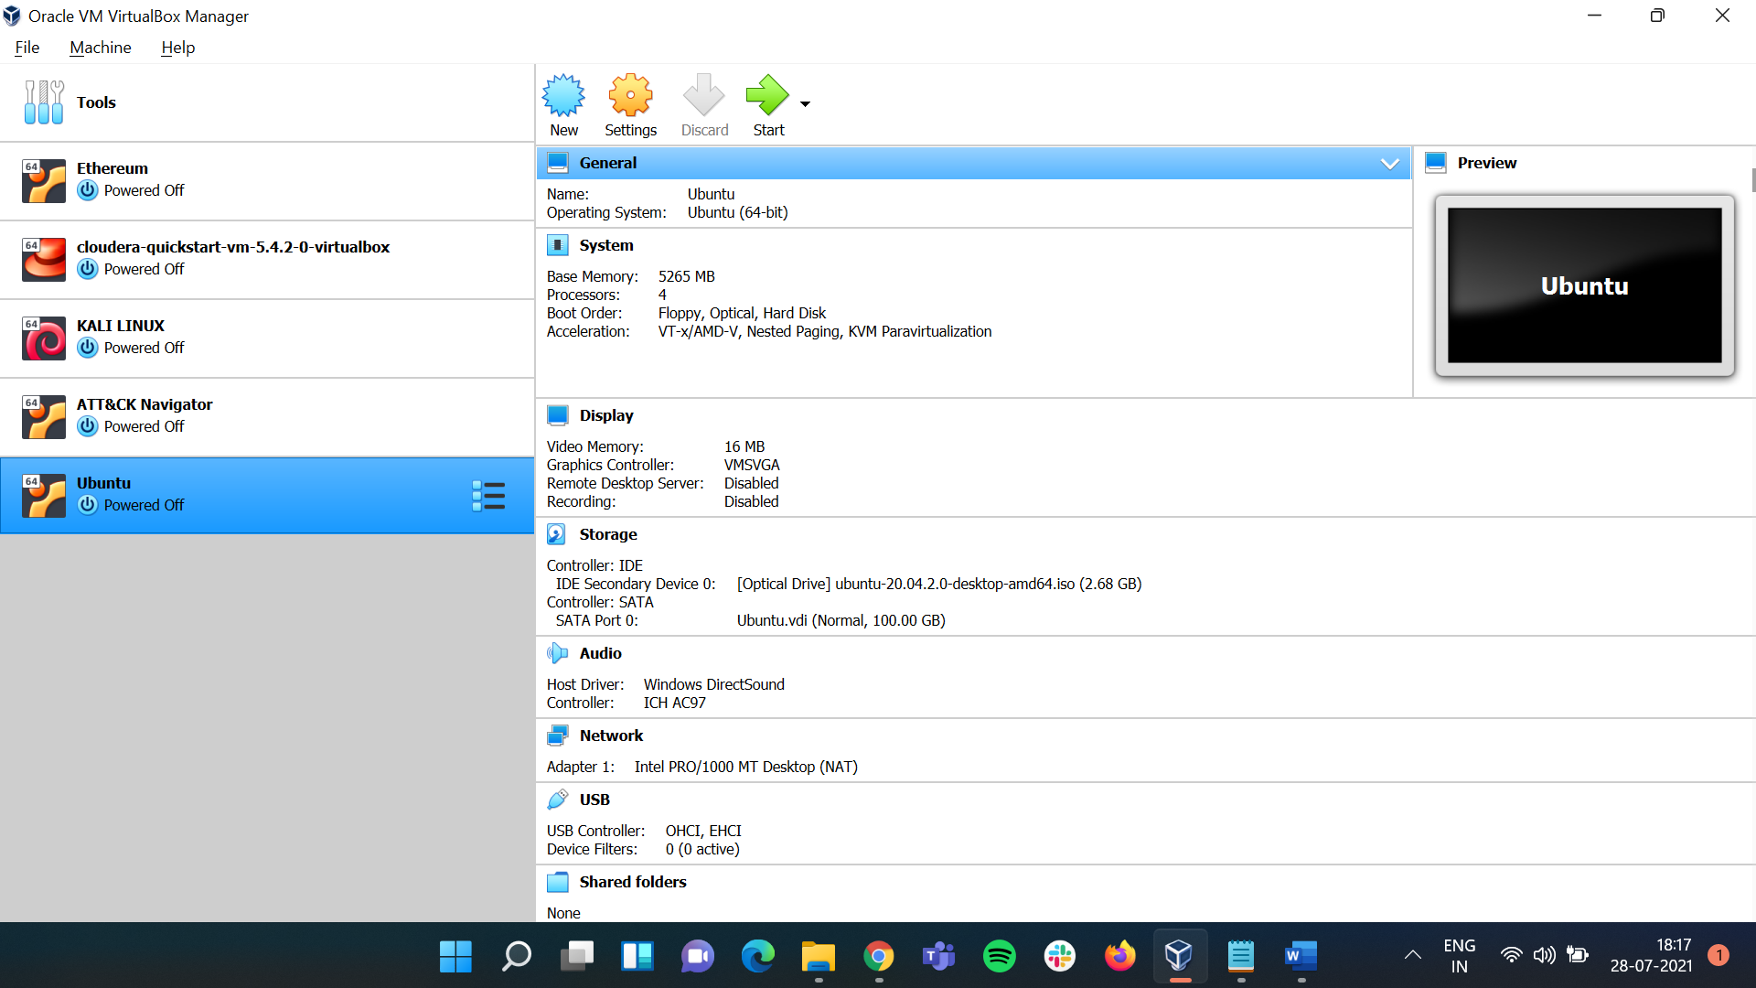

## Once the above steps are followed click on **Start.**

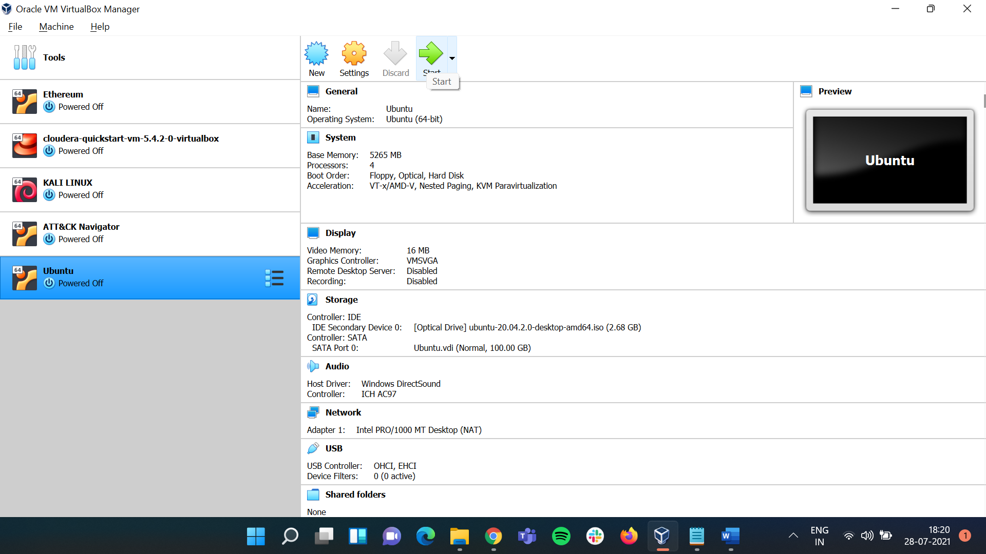

## Once clicking on **Start** a new window will open with Ubuntu here set the language as **English** and Ubuntu will start up.

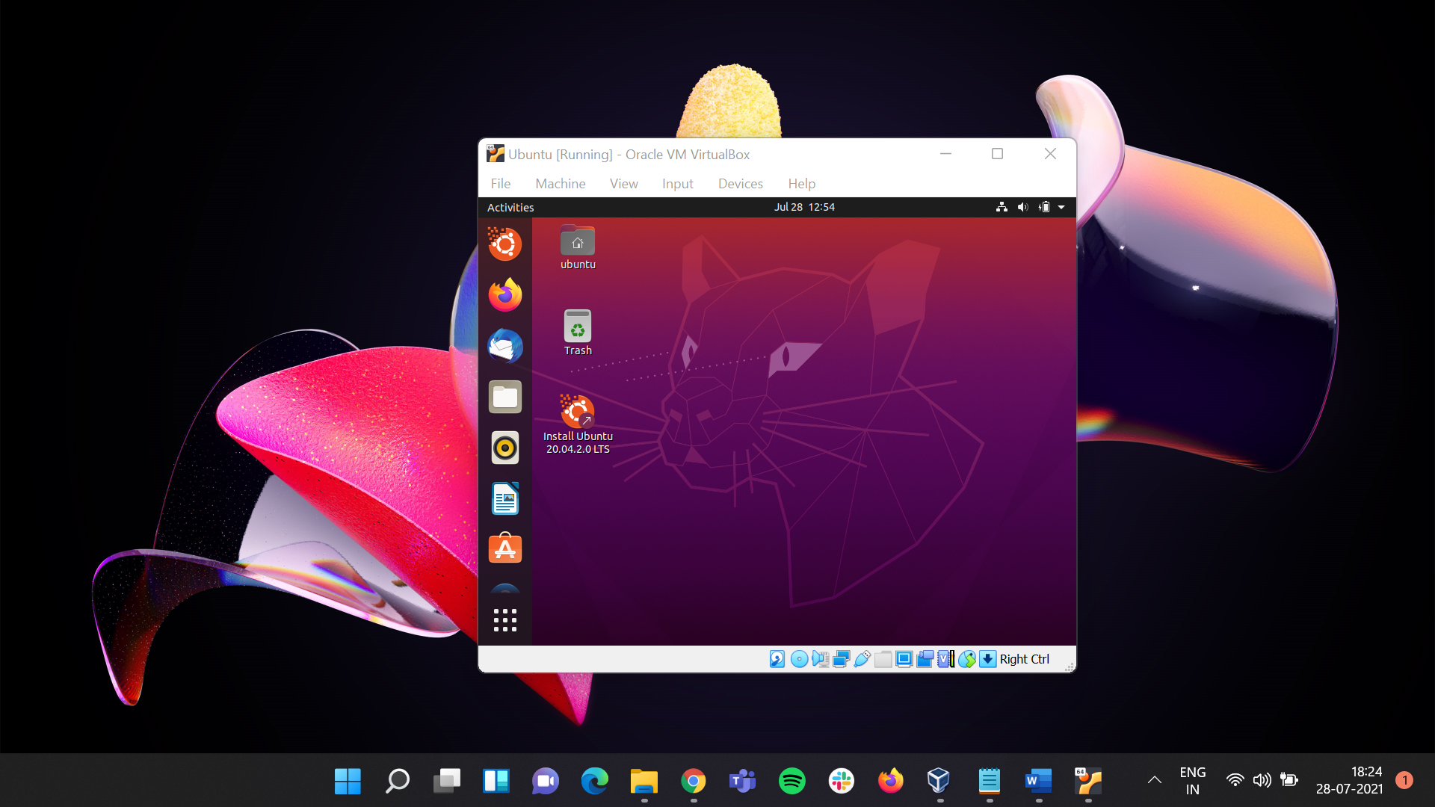

## After this **Maximize** the **Main window** there you will see the **Ubuntu window** is not same as the main window.

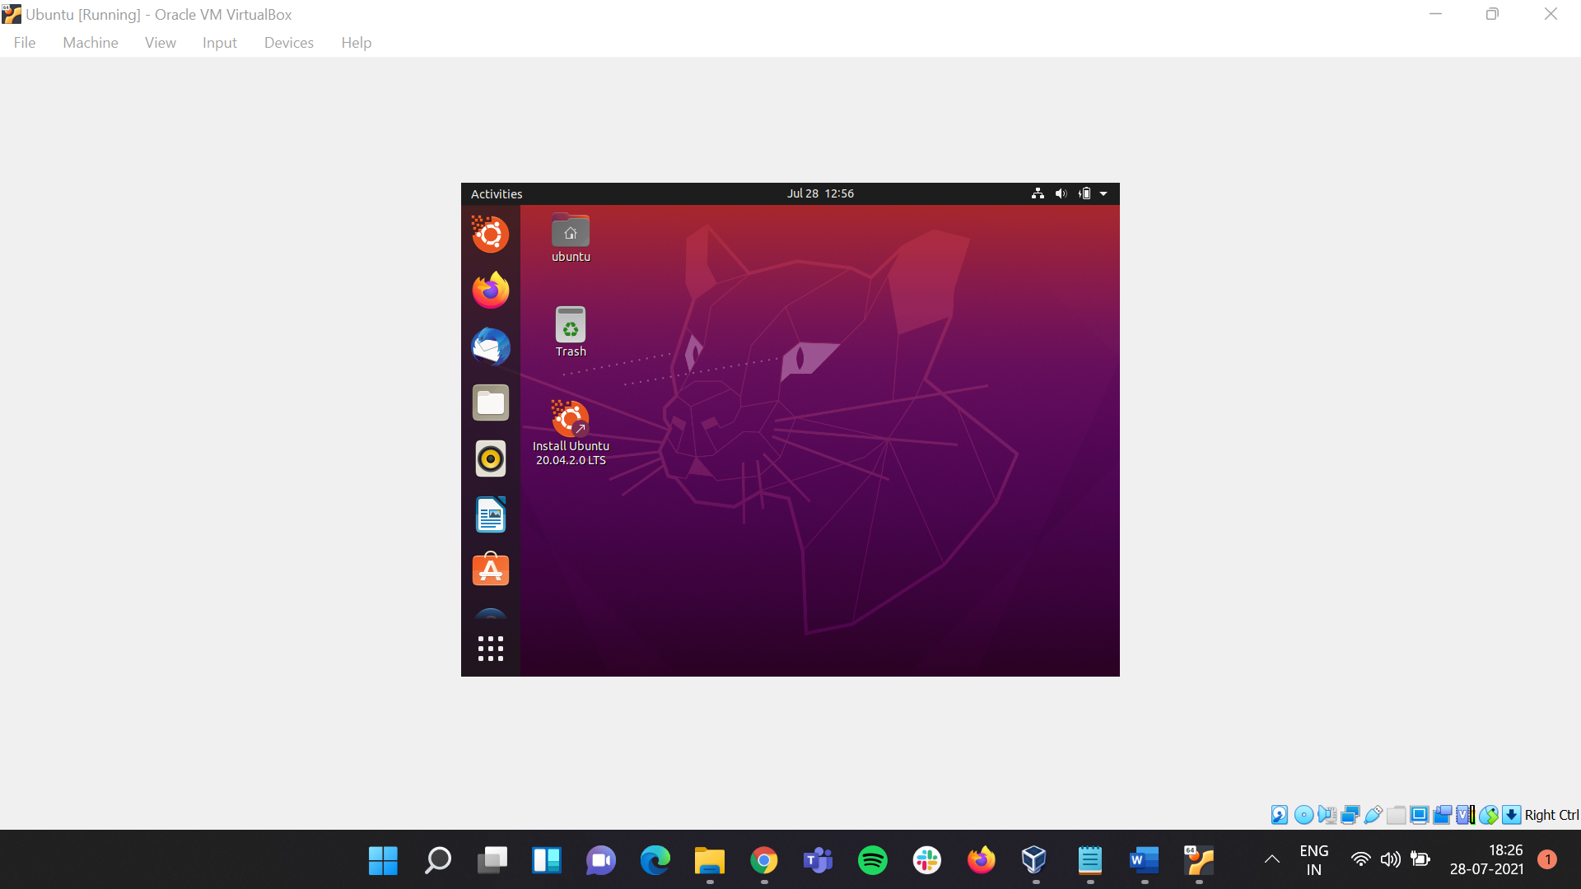

## To resolve the error, open the **cmd** in Ubuntu and run the following code: **$ sudo apt install build-essential dkms linux-headers-$(uname -r)** and follow the rest of instructions

## Once the code has been run successfully exit the **cmd** and click on **Devices** under that click on **Insert Guest Additions CD Image**. Then there will be a prompt click on **Run.**

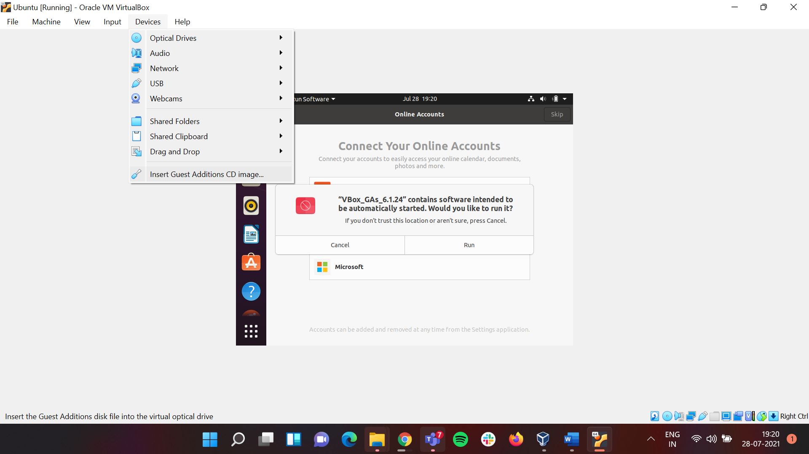

## It will ask for password add the password and click on authenticate

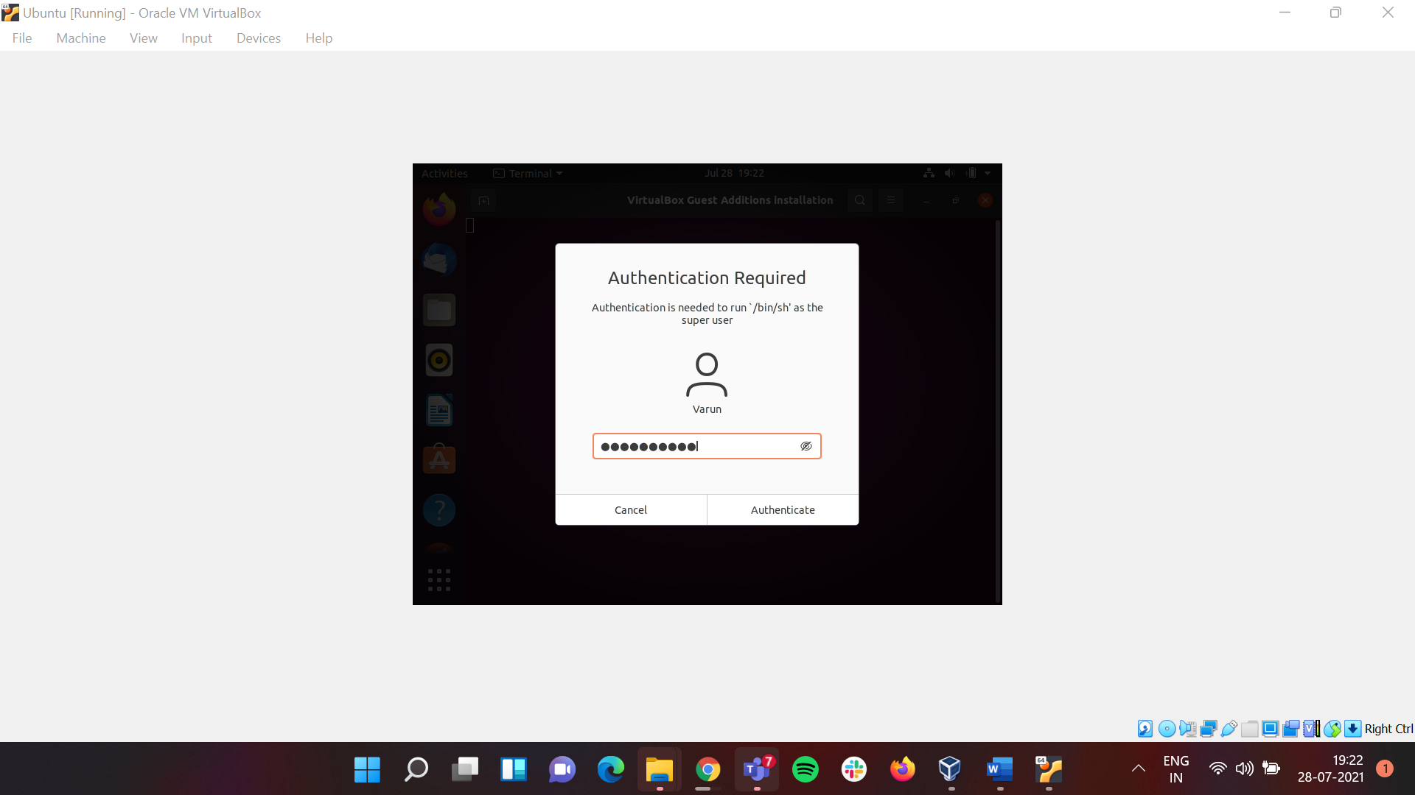

## Now **Restart** Ubuntu

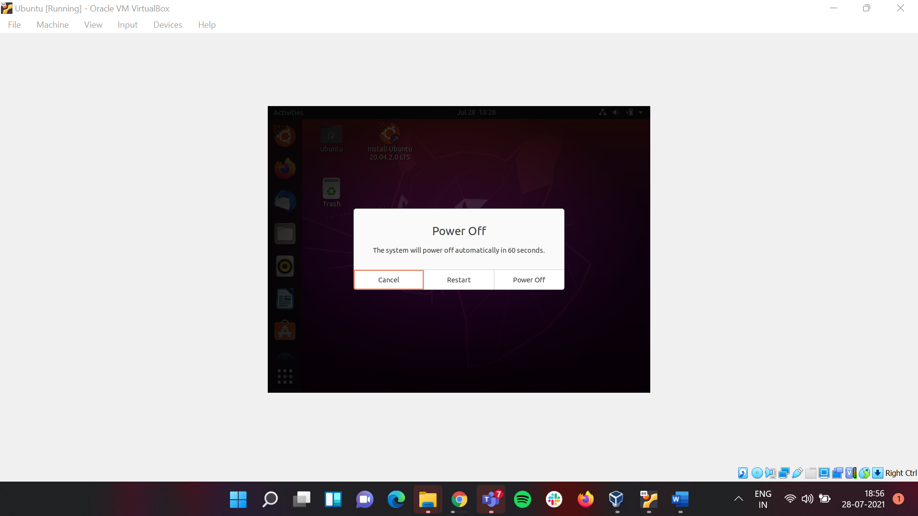

## Hence you can see the issue has been **resolved**.

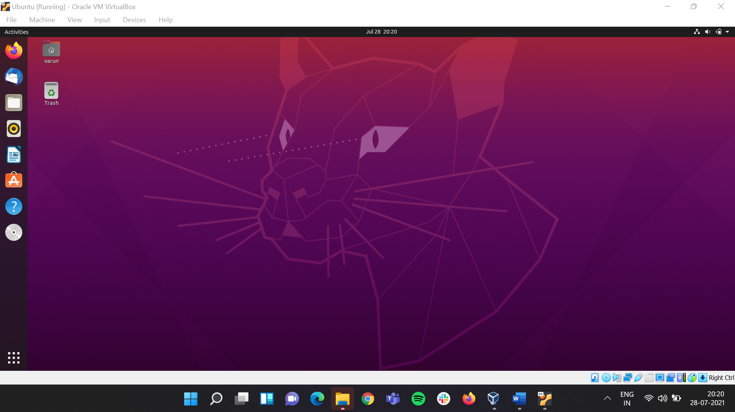

# Conclusion

Hence we were able to install Oracle VM and Ubuntu on Windows OS.